Contents

82. Brief Introduction to **Workflow** 2

83. Brief Overview of **Workflow Console** 4

84. Creating **Workflow** 10

85. **DAM Update Asset Workflow** 17

86. **Managing Digital Assets** 24

# 82. Brief Introduction to **Workflow**

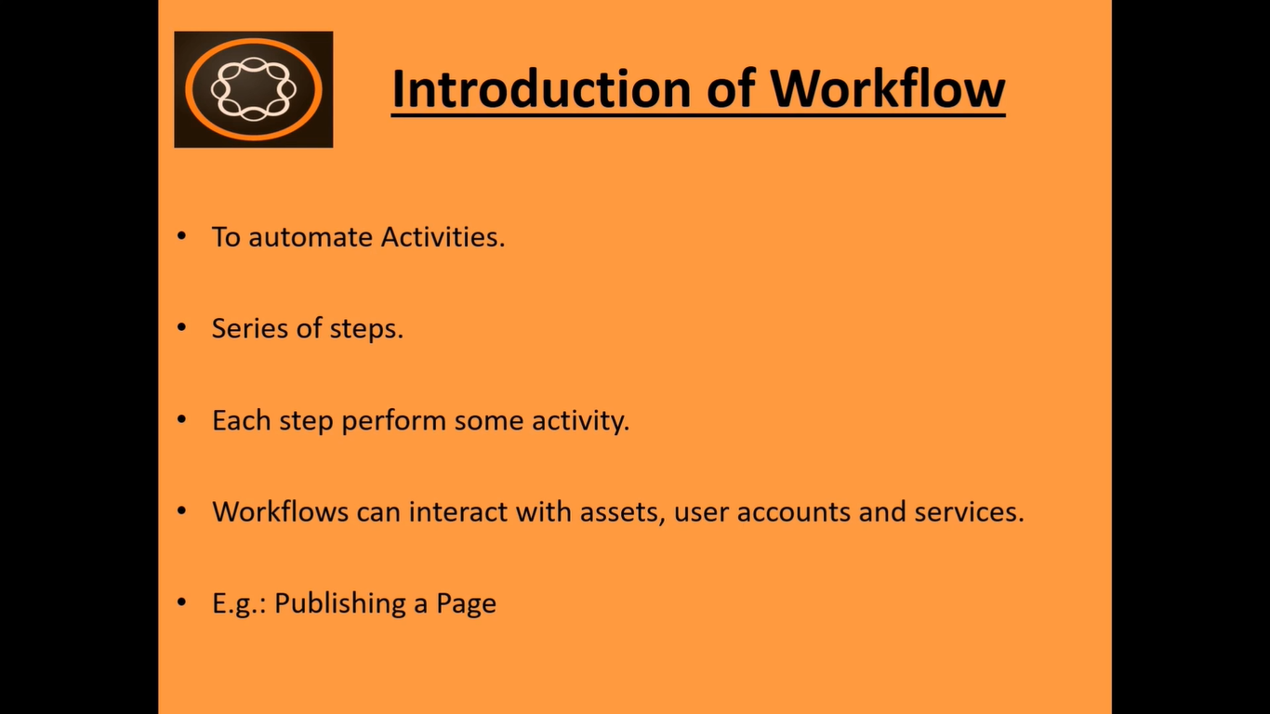

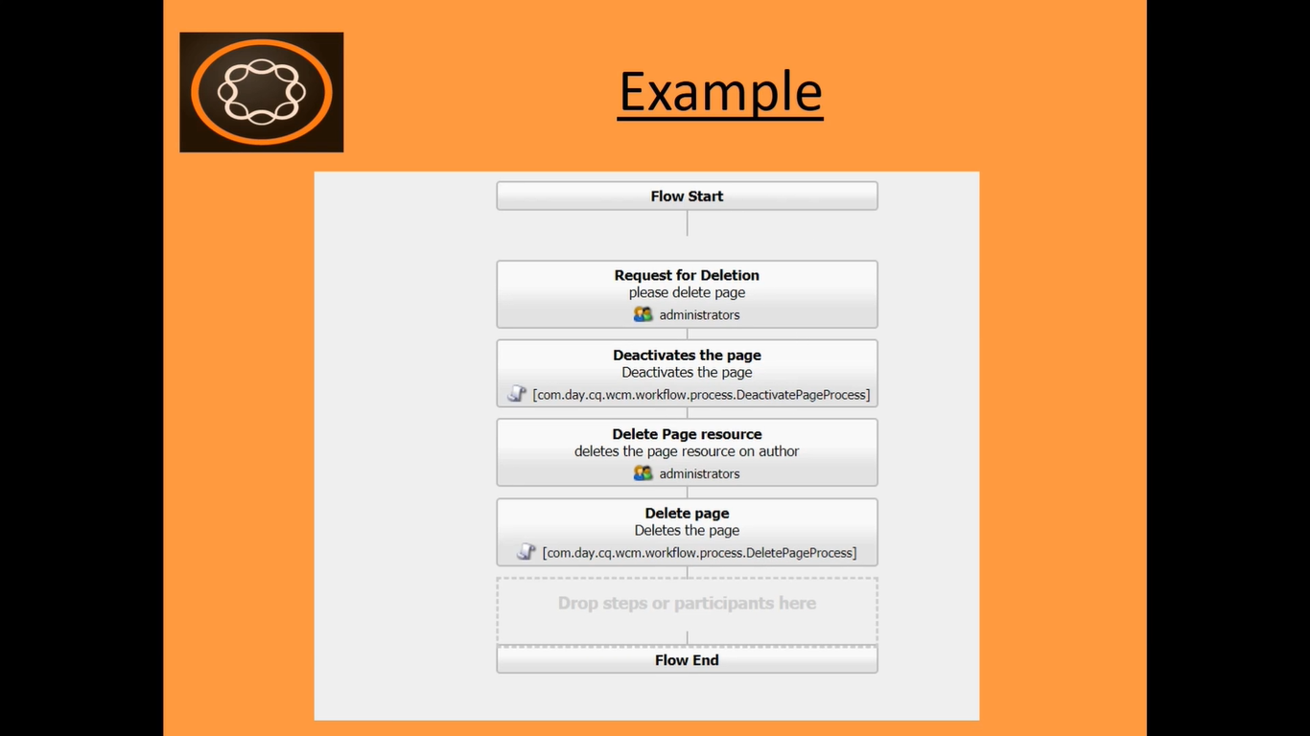

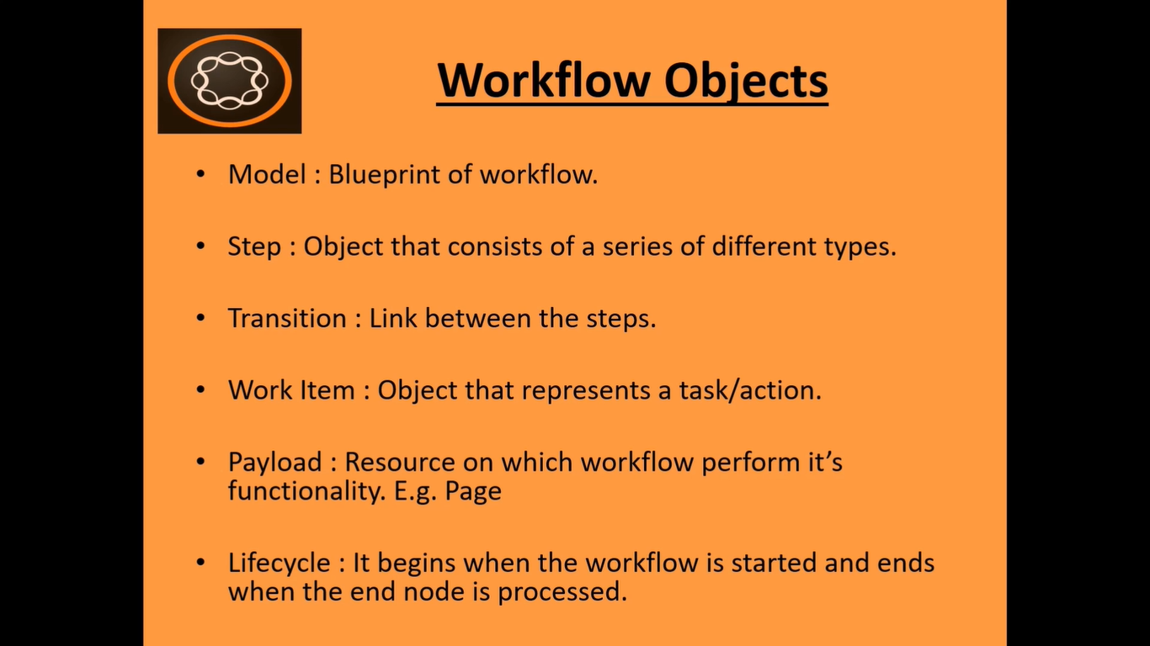

# 83. Brief Overview of **Workflow Console**

Go to **AEM** --> **Tools** --> **Workflow** --> **Models**

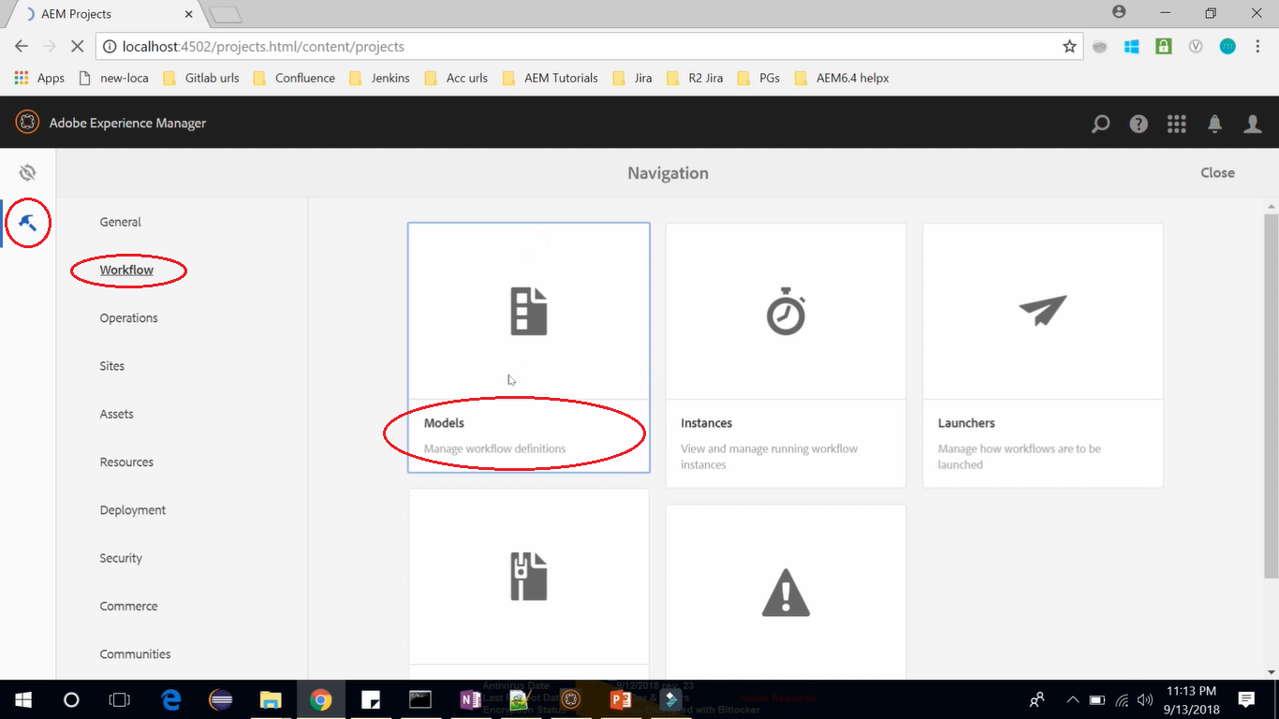

Here you can find lots of workflow models which are already available out of the box in AEM.

Switch from **Cards View** to **List View** (click highlighted icon button)

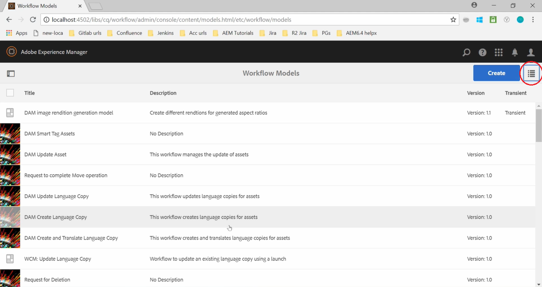

We can also create our custom Workflow Model by clicking Create button on Toolbar --> Create Workflow.

It will open below dialog box where we can put Title and Name and we can start creating our new Workflow Model.

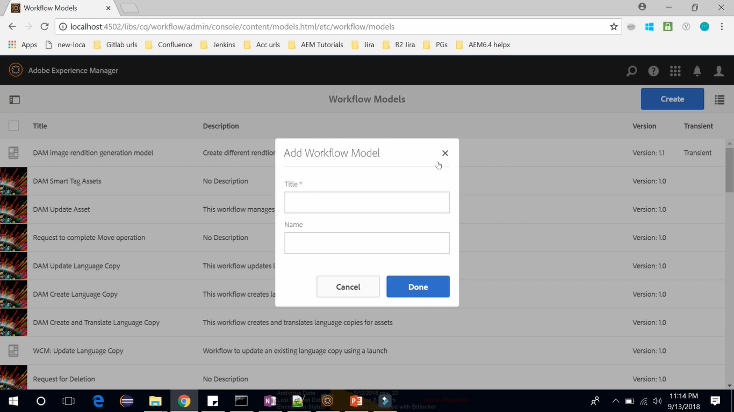

If you **select** any existing Workflow Model, you can **Edit**, **Start** or **Delete** selected Workflow Model.

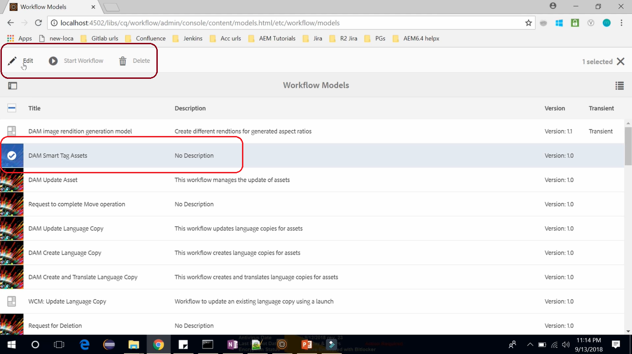

Click to open **Instances**. Even though it is empty, you can see workflows which are currently in progress.

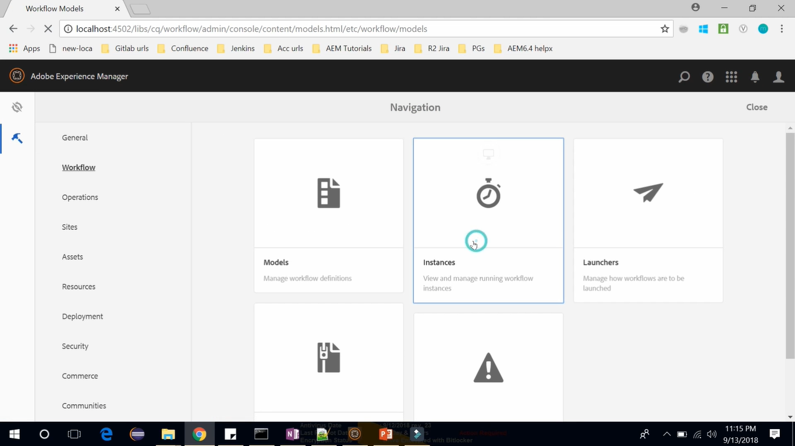

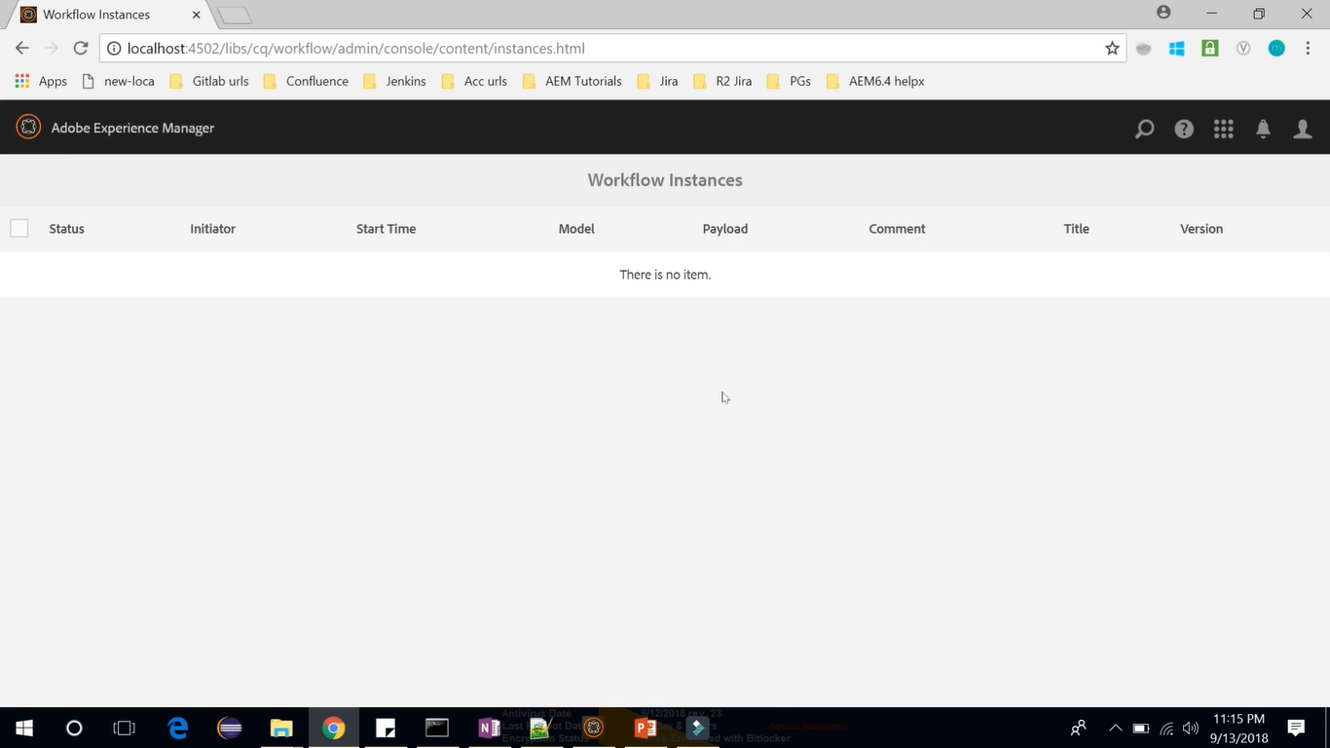

Click to open **Launchers**. Launchers allows to define a workflow to launch a specific event occurs in AEM.

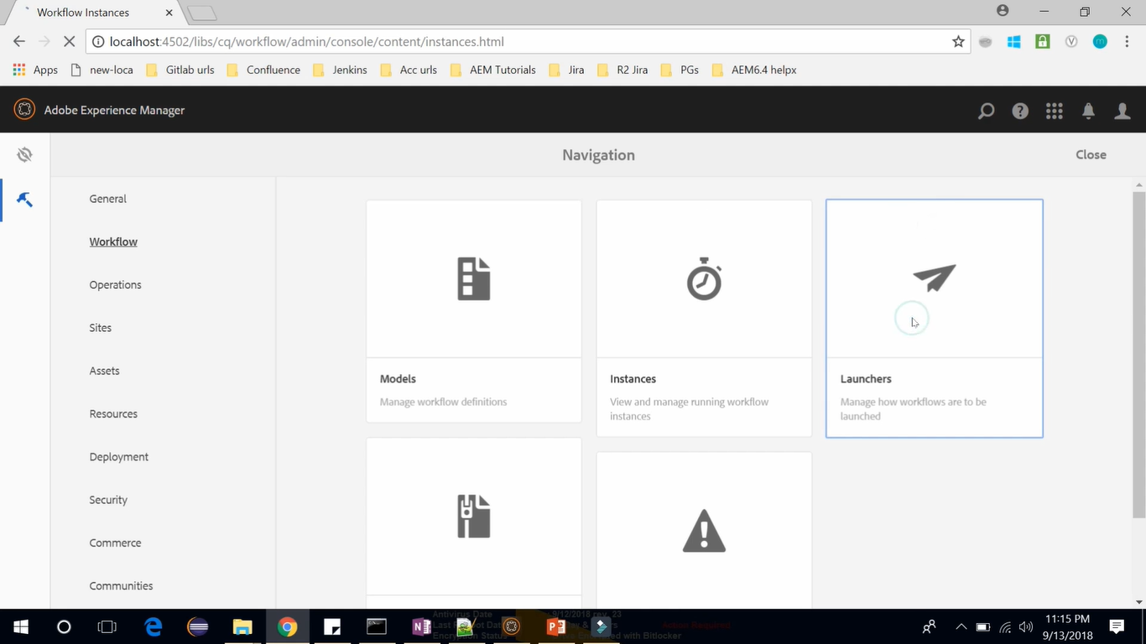

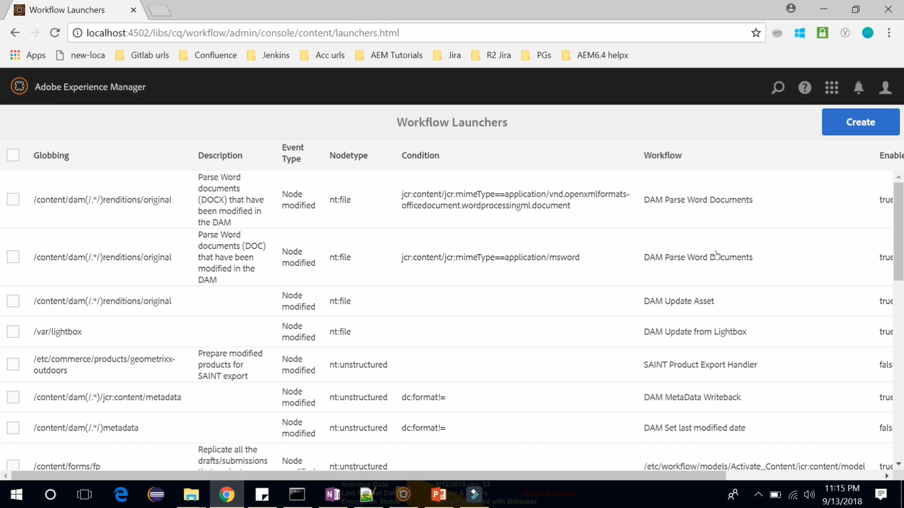

Above are the launchers already present. The first column Globbing represent the paths specified for the action of node. You can also select any of the Launcher to View its properties or delete it. (image below)

You can also create new Launchers by clicking **Create** button on Toolbar --> **Add Launcher**

While creating a new Launcher, you can define Type of Event, when you want to execute Workflow Model, you can define which workflow model to execute. (See the image below)

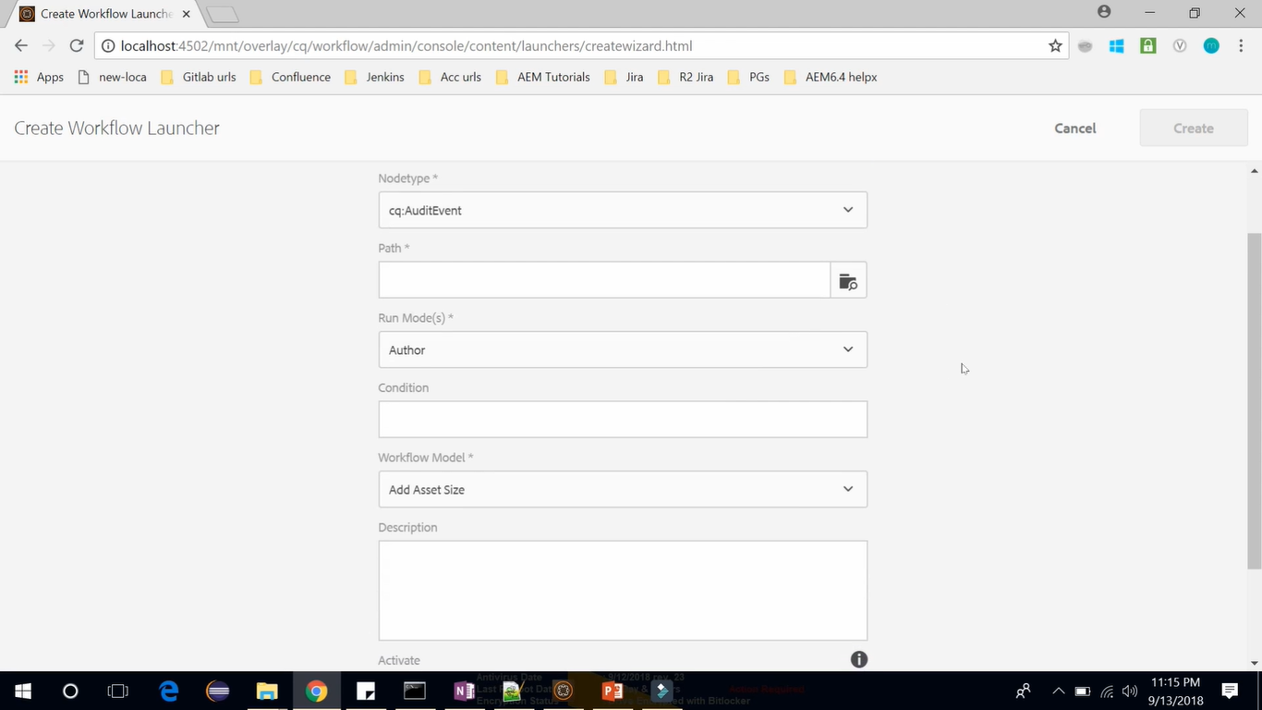

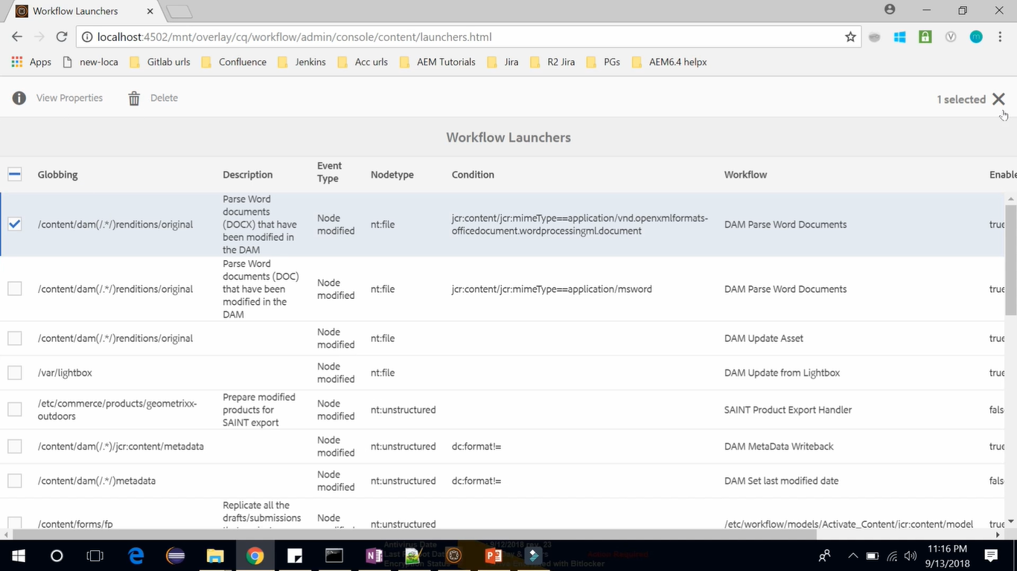

The next is Archive (see image below). Even though, there are no records for archive, you can find details of a workflow instances that have completed or terminated.

You can also view the history of the workflow here.

Next is Failures (see image below). In this console you can find workflows which have been failed.

AEM Users have their own workflow inbox (Notification icon) in which their assigned workflows are accessible.

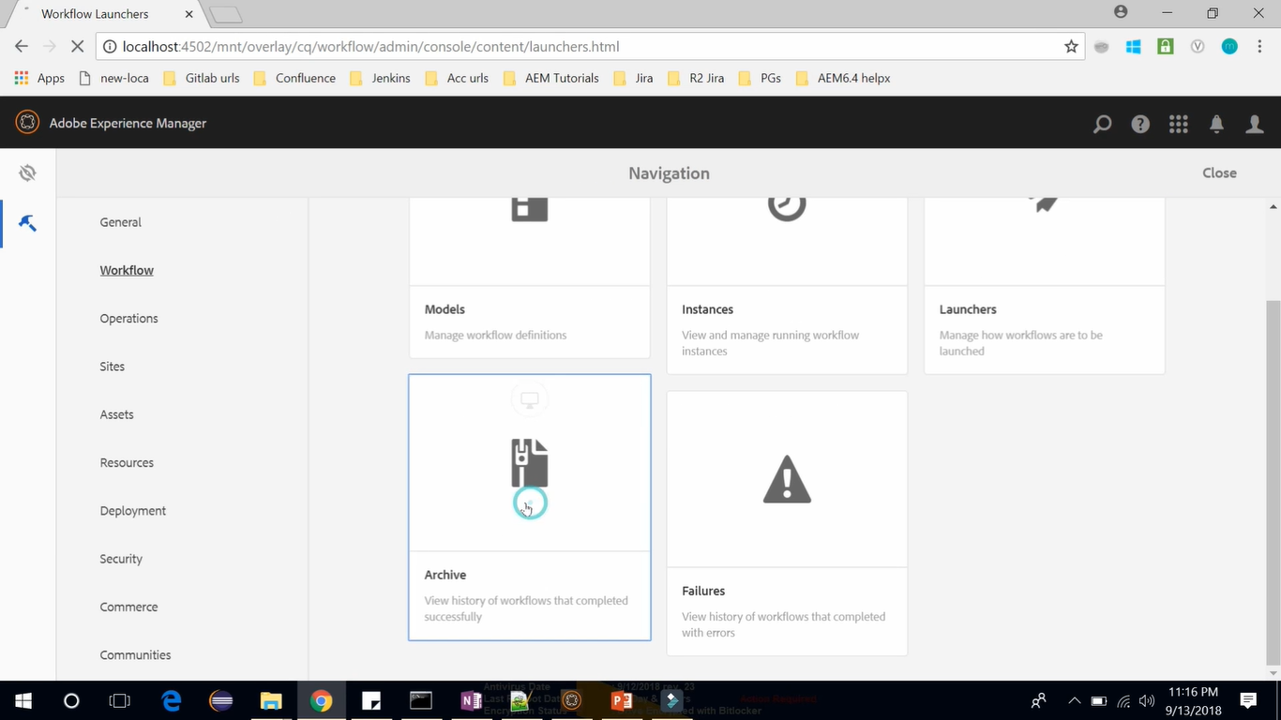

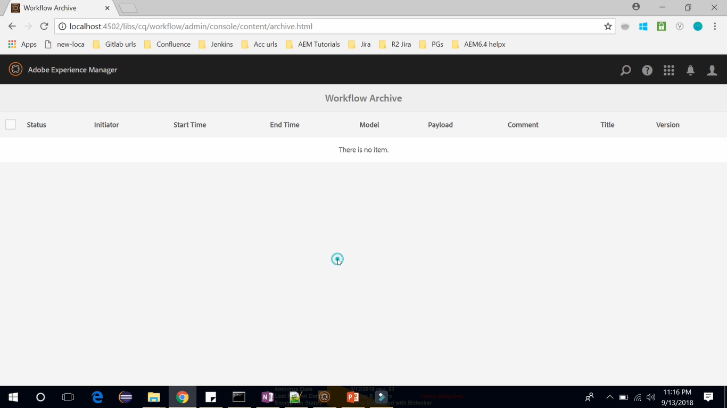

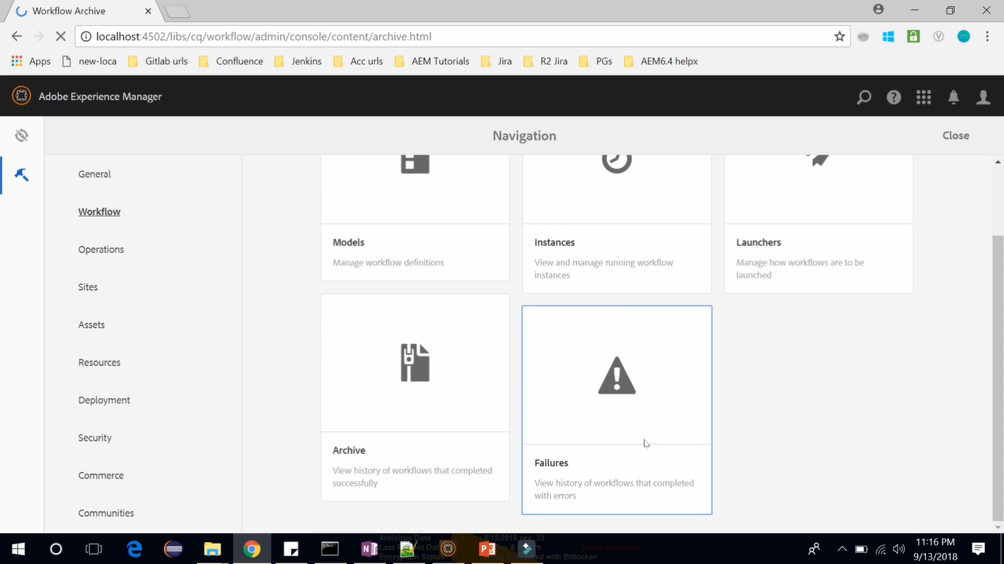

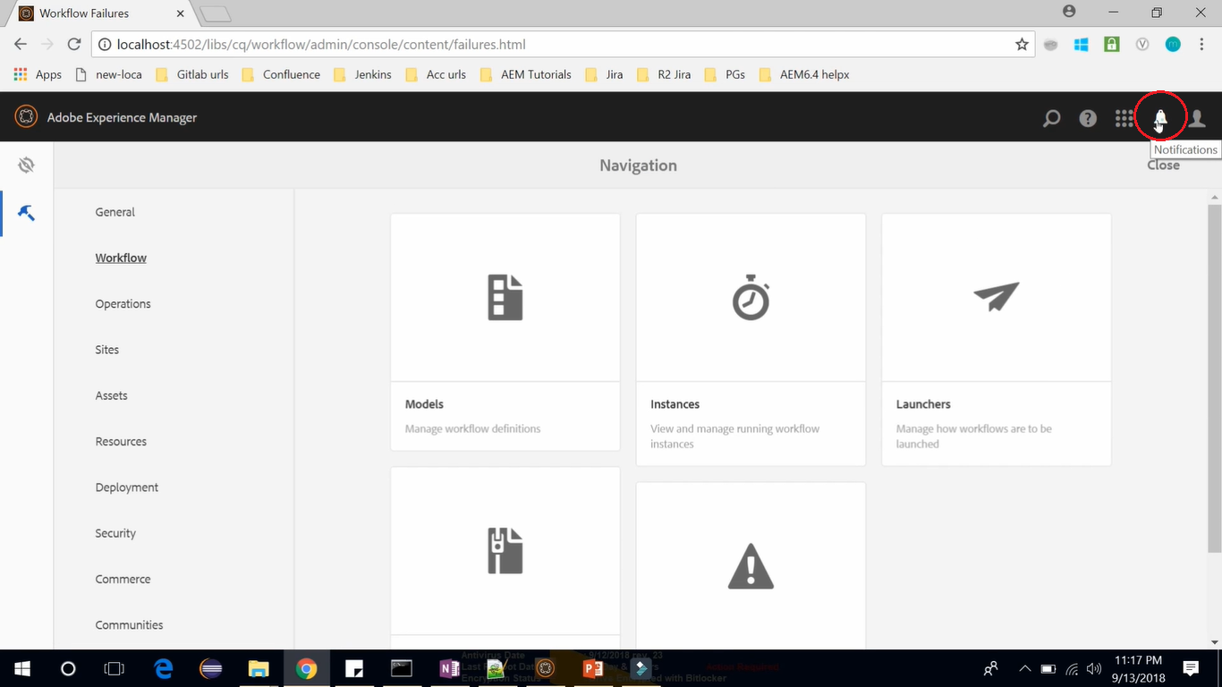

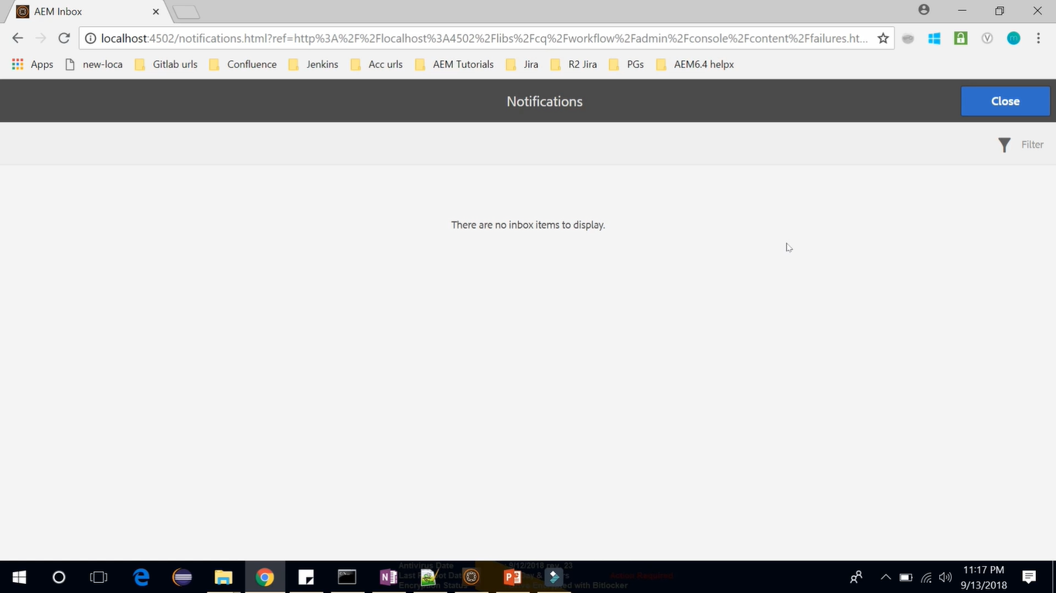

# 84. Creating **Workflow**

Let’s create a custom **Workflow Model** to *automate* the **Page Publishing Process** in AEM.

To open Workflow Console, go to **Product Navigation** (click AEM logo) --> **Tools** --> **Workflow** --> **Models**

**Create** --> **Create Model** --> **Title** (Request for Publishing) --> **Done** --> **Select** it --> **Edit** icon



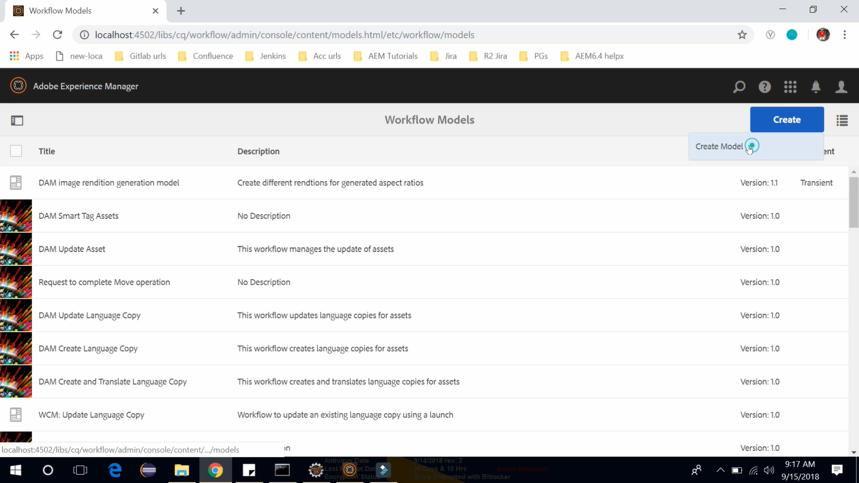

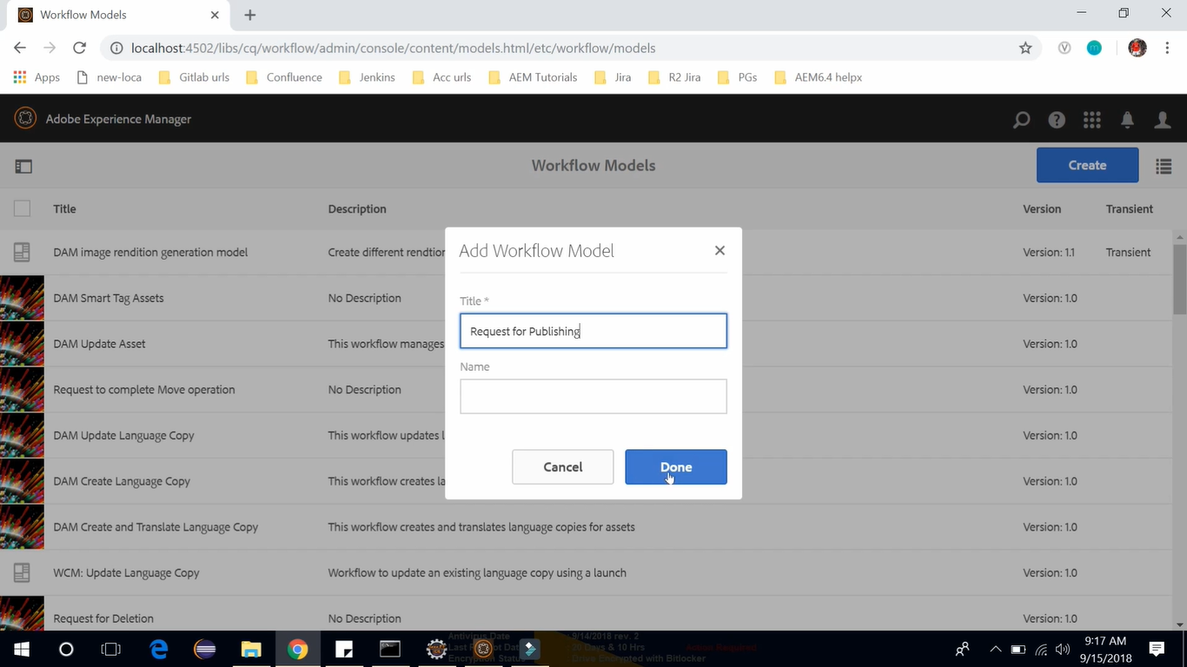

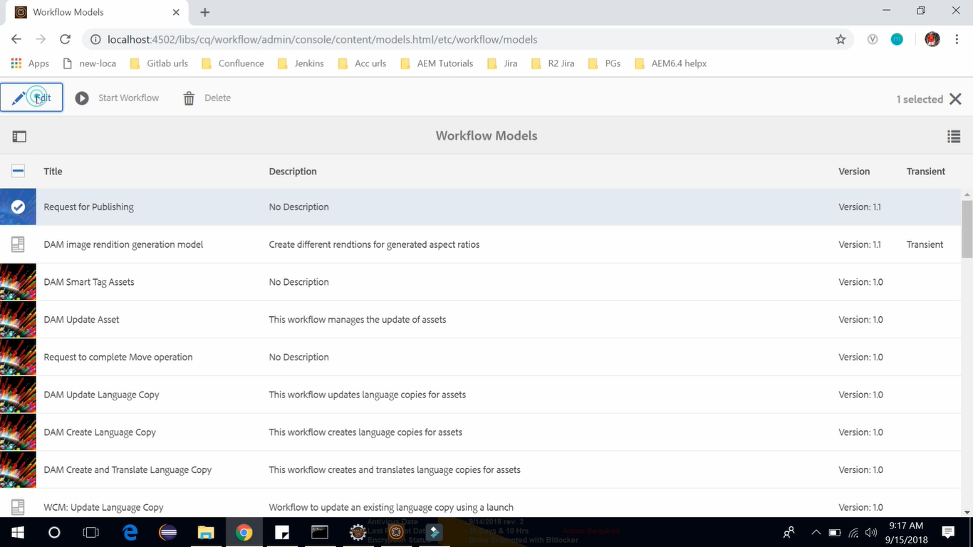

It will open a **Workflow Editor Console** where we can Edit our Workflow Model.

Notice that here we have **Flow Start** and **Flow End.** Also notice that we have a **participant step.**

Let’s select it and click on Delete button to Delete it.

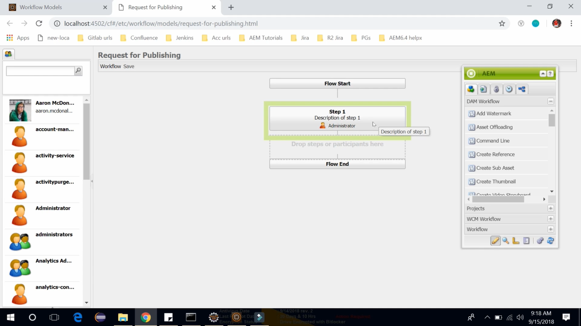

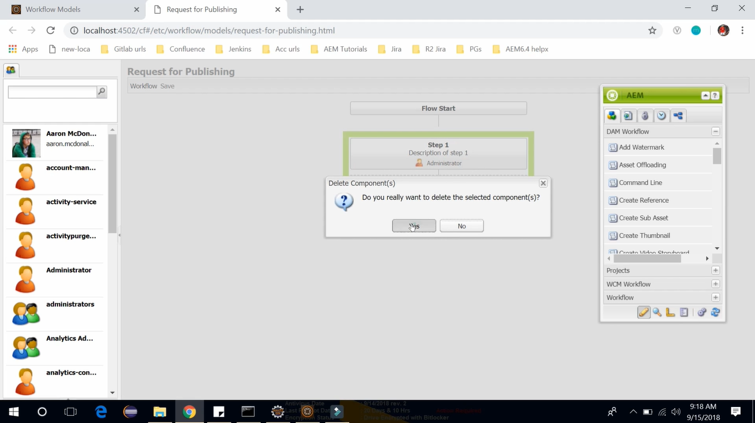

That deleted step was the Participant Step. Let’s see how we can select it and add it in our Workflow.

Drag a **Participant Step** component (under **Workflow** section) from **Component Browser** dialog/window and drop it between **Flow Start** and **Flow End**.

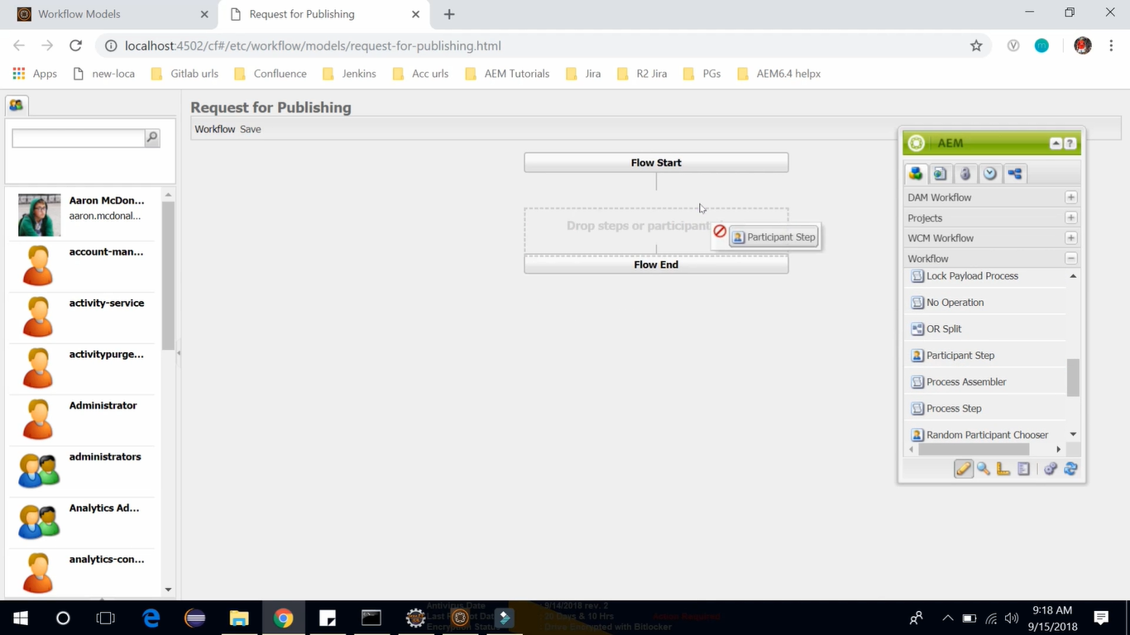

**Double click** on this newly added **Participant Step** component. It will open **Step Properties** dialog/window.

Give **Title** and **Description** mentioned in the below image. On **User Group** tab select **Administrator** group.

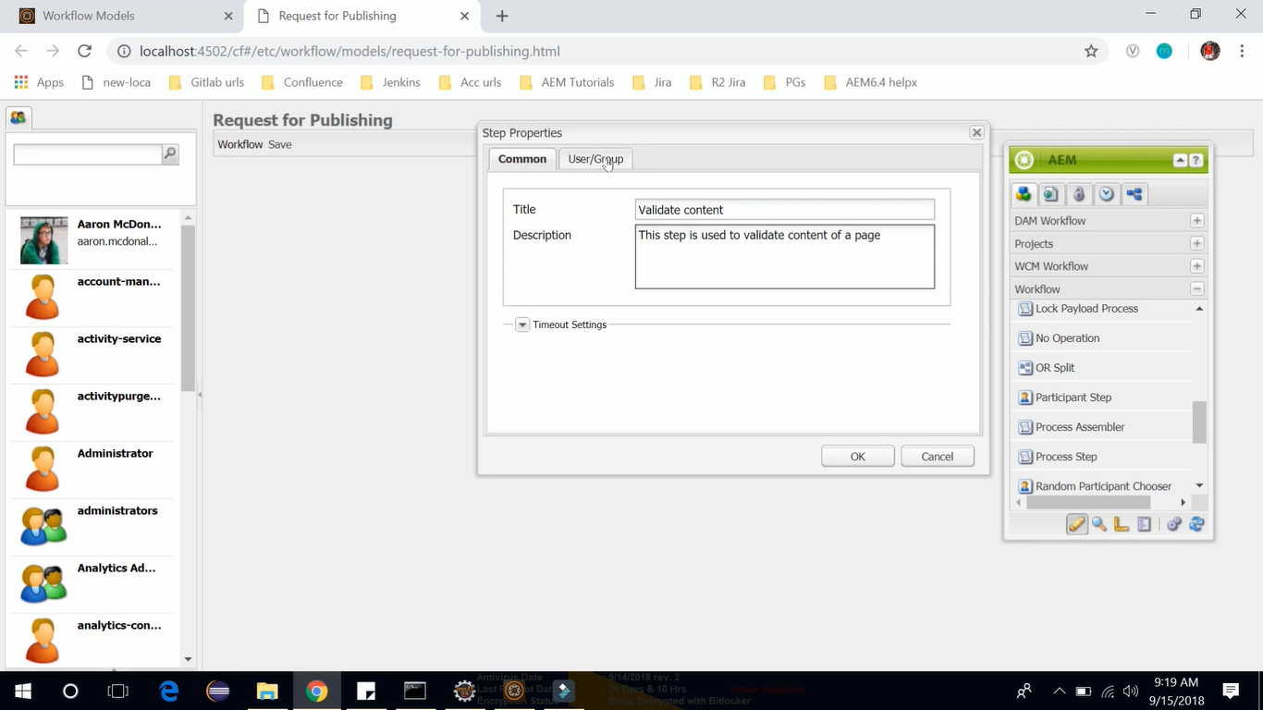 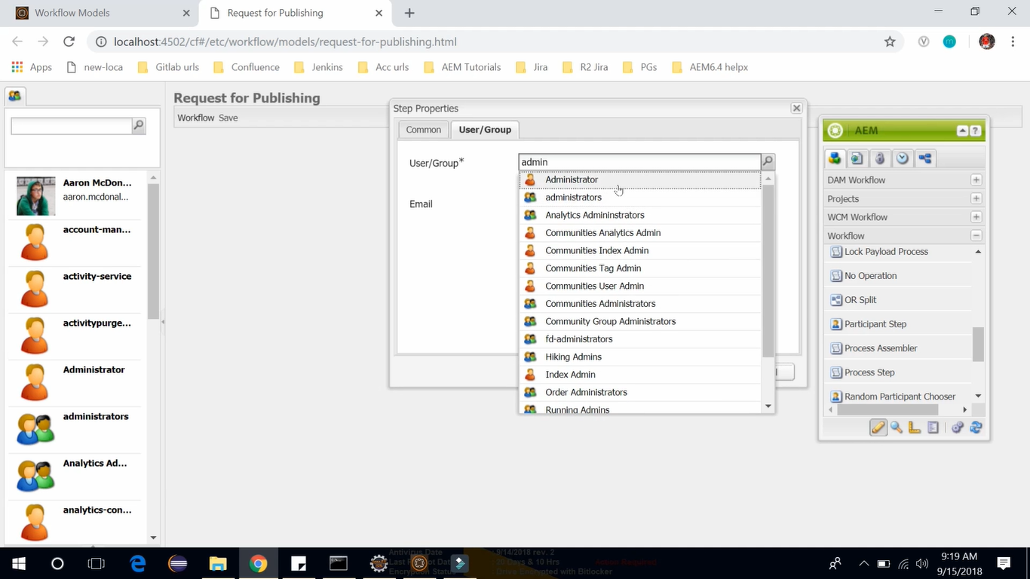

Drag a **Activate Page/Asset** component (under **WCM** **Workflow** section) from **Component Browser** window and drop it before **Flow End**.

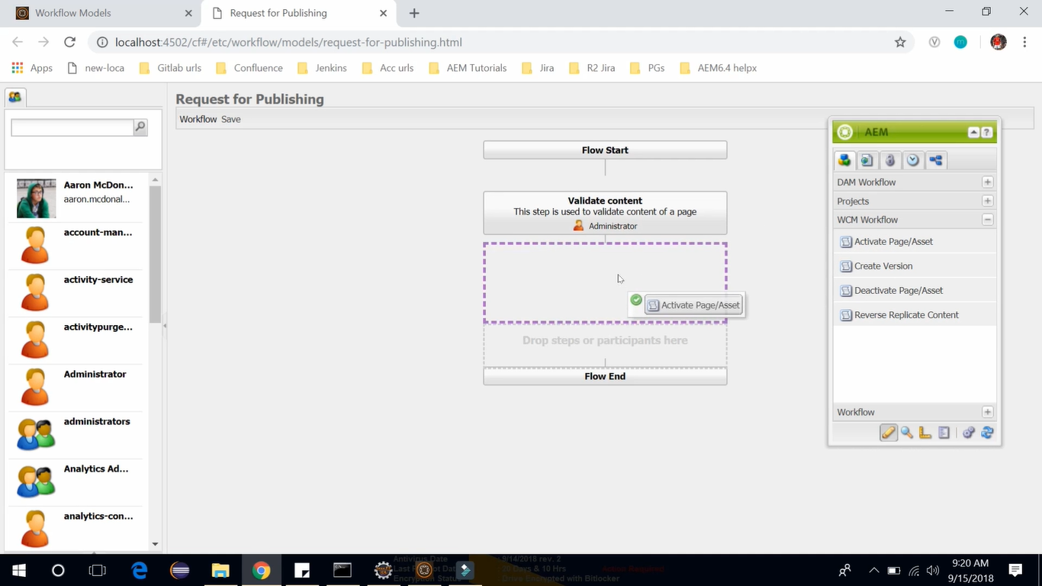

**Double click** on this newly added **Activate Page/Asset** component to open and edit its **Properties**.

Give **Title** and **Description** mentioned in the below image. Click on **OK** button to **Save** it.

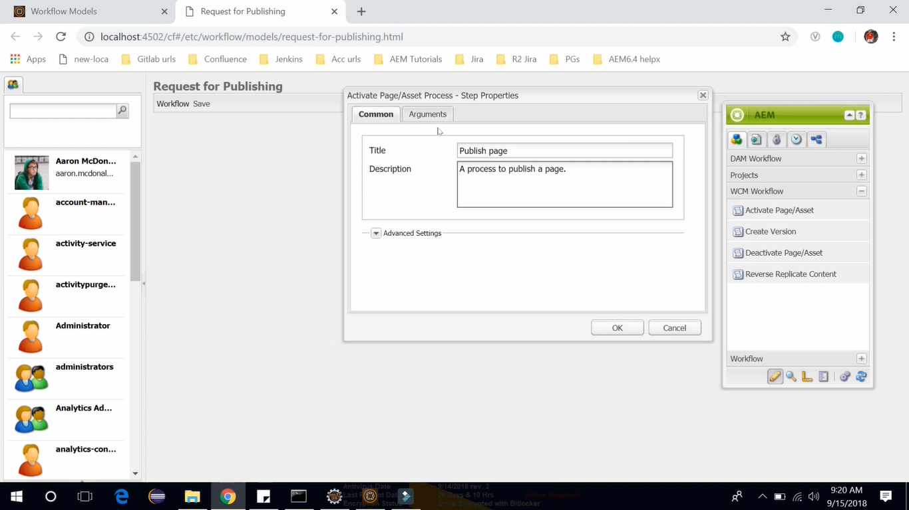

Now look at the Workflow from the starting. We have **Flow Start** Step to start the Workflow, next we have **Validate Content** step for Validating the content of the page, after the validation is completed we have **Publish Page** step which will publish this page, and at the last **Flow End** step which will end the Workflow.

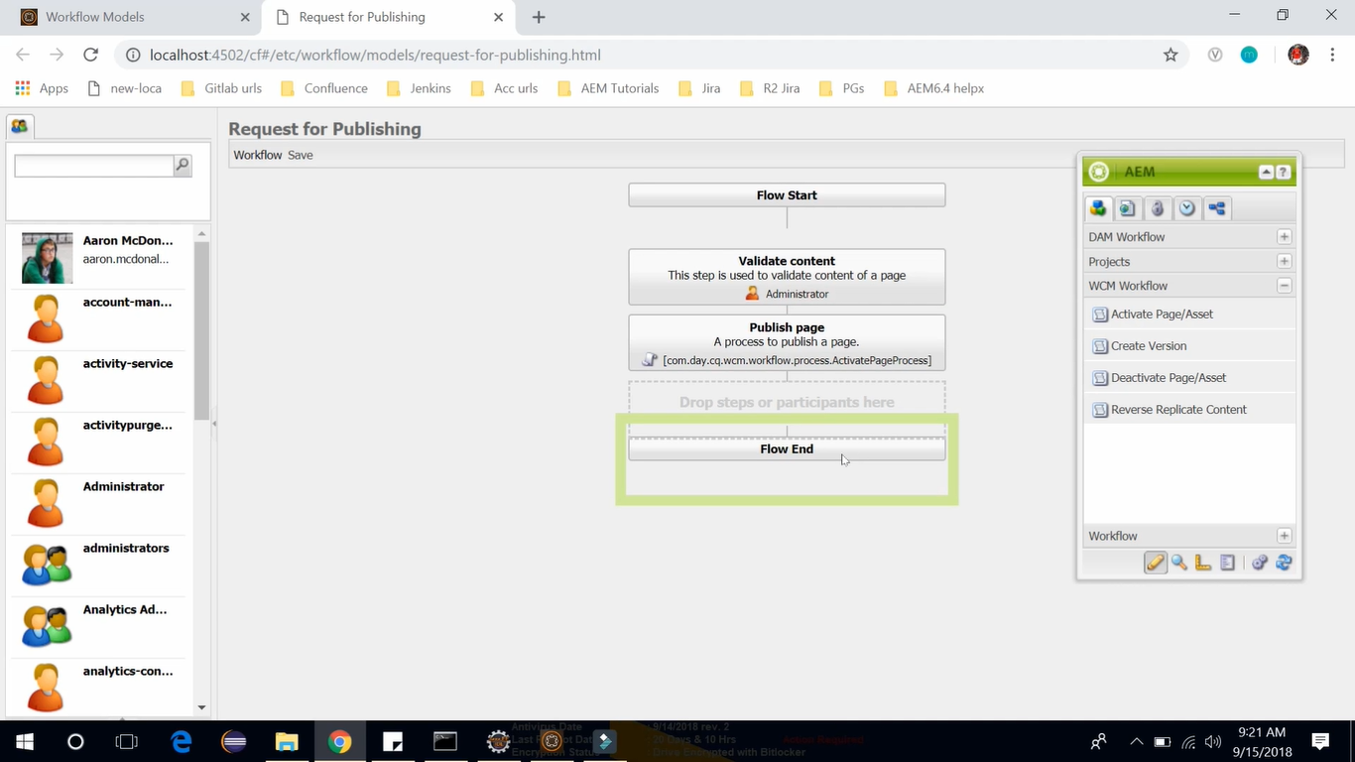

The mechanism for publishing these pages is built into that Workflow options.

Once you will execute this workflow, we will get the notification in our AEM asking us to valiadate the page. Once we Validate the page, the next step withing the workflow is to Publish the Page.

Click on **Save** button present on top of the page (below text Request for Publishing) to **Save** the **Workflow**.

Once Workflow is saved, select the Workflow and click on **Start Workflow** icon button.

It will ask for the **Payload**. **Payload** is a resource on which **Workflow** will perform its functionality.

In our case, it is **Page** which we want to **Publish**. Click on **Browse** button. Select Page from below Path

**Content Root** --> **Geomatrixx Demo Site** --> **English** page --> Click on **OK** icon on top right corner.

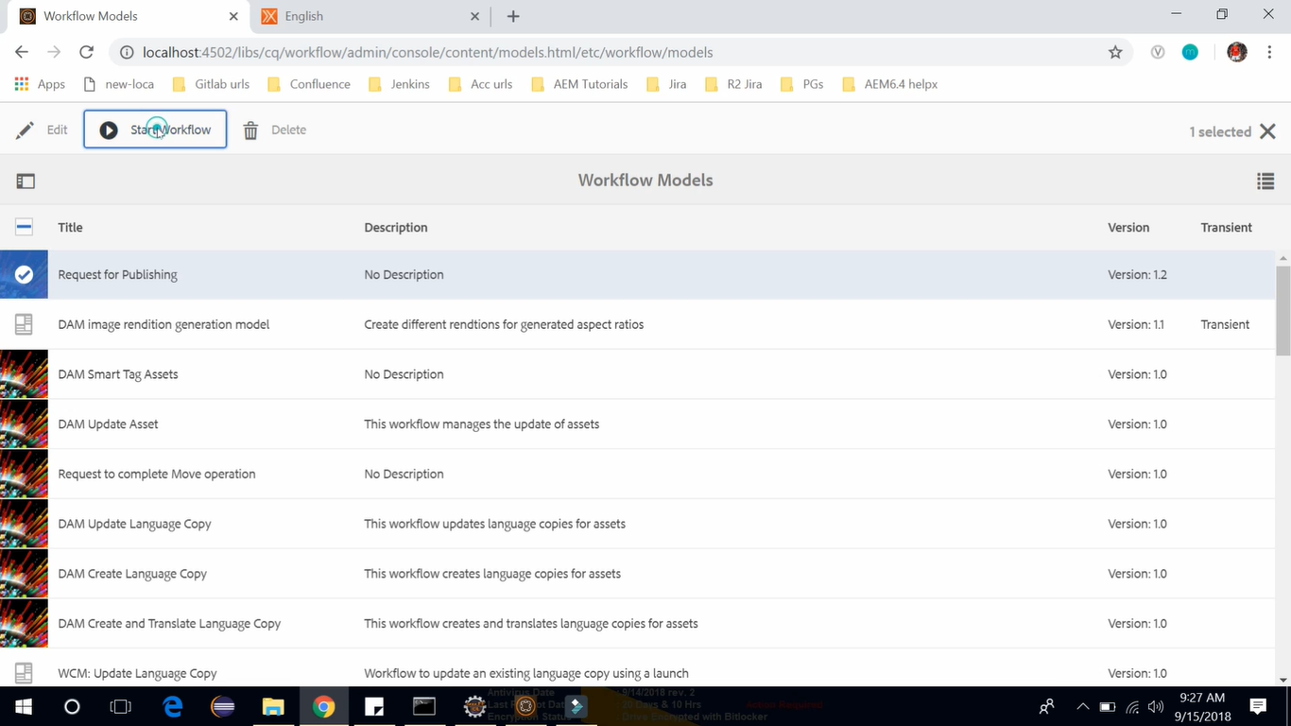

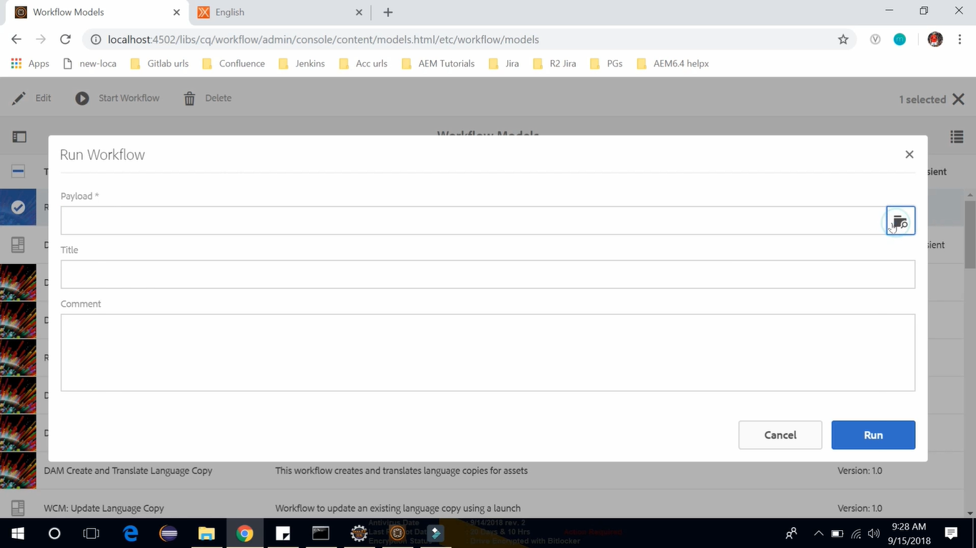

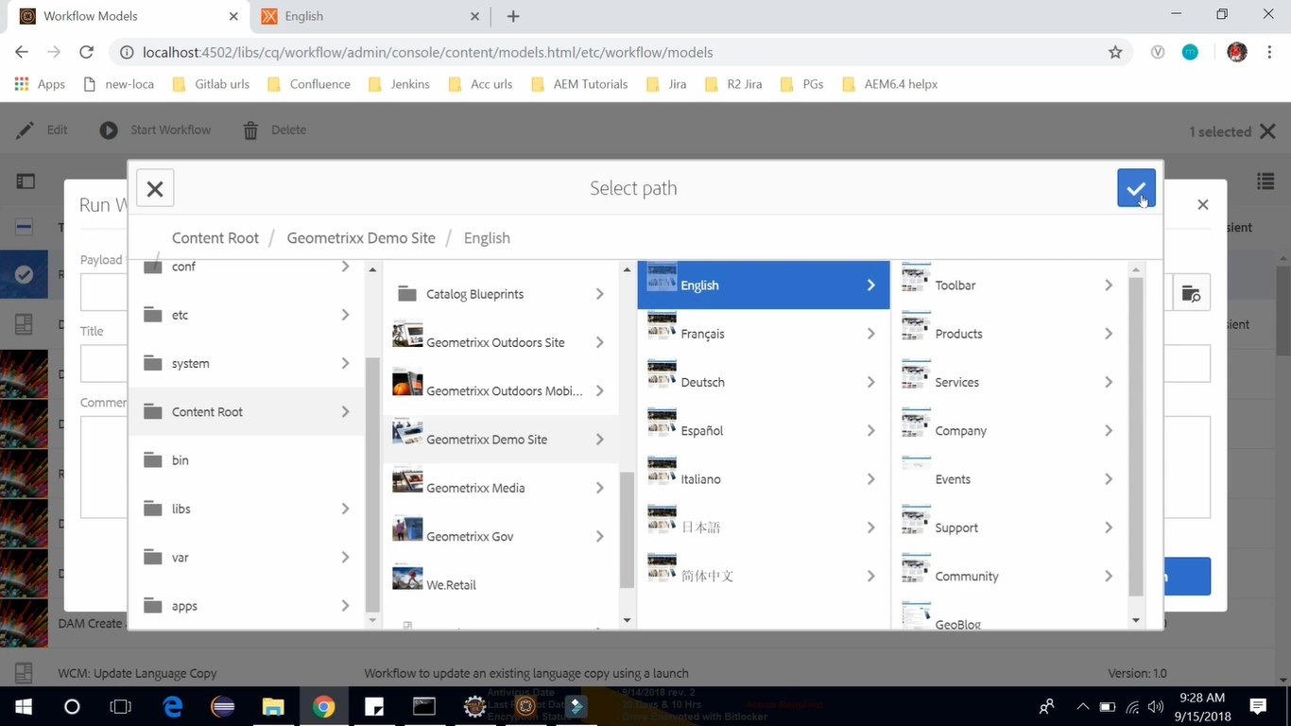

Give **Title** as “Publish the Page”. It will run our Workflow. You can see a message on top as “WORKFLOW STARTED”. After successful run of the Workflow, it will show the message “SUCCESS The form has been submitted successfully”. Now go to the **Notification** by clicking its bell icon on top right corner.

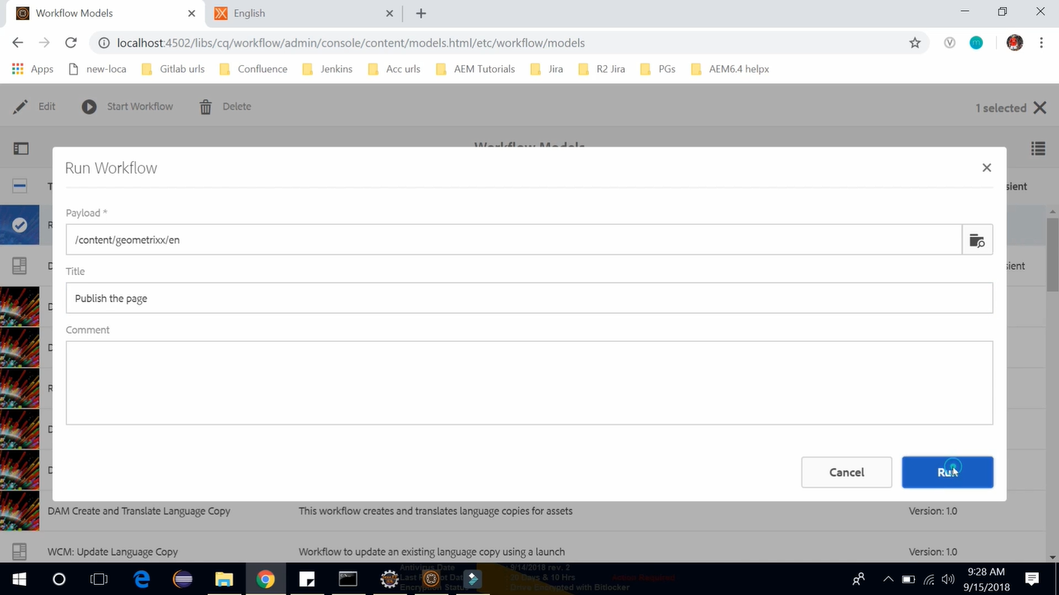

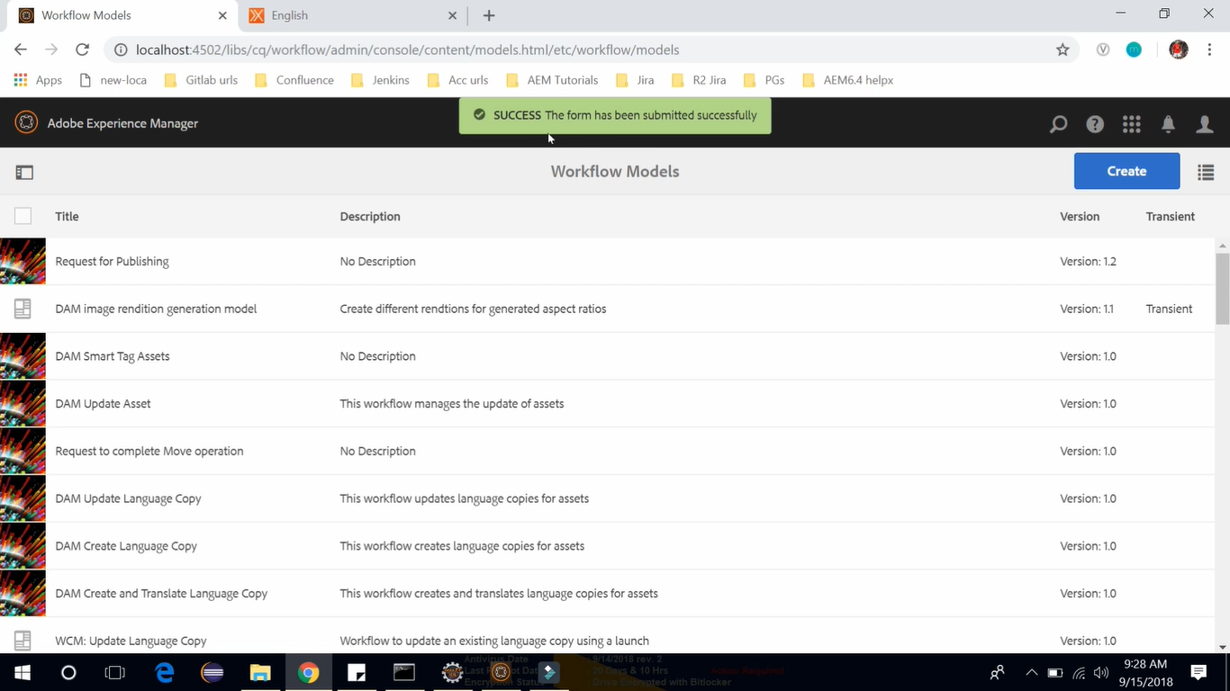

We have received a notification. It has shown our **workflow name** in yellow “**REQUEST FOR PUBLISHING**” with a step **Validate Content**.

Check this notification checkbox --> click on Complete button on Toolbar.

Now the Validation has been completed and it will show the next step **Publish the Page**.

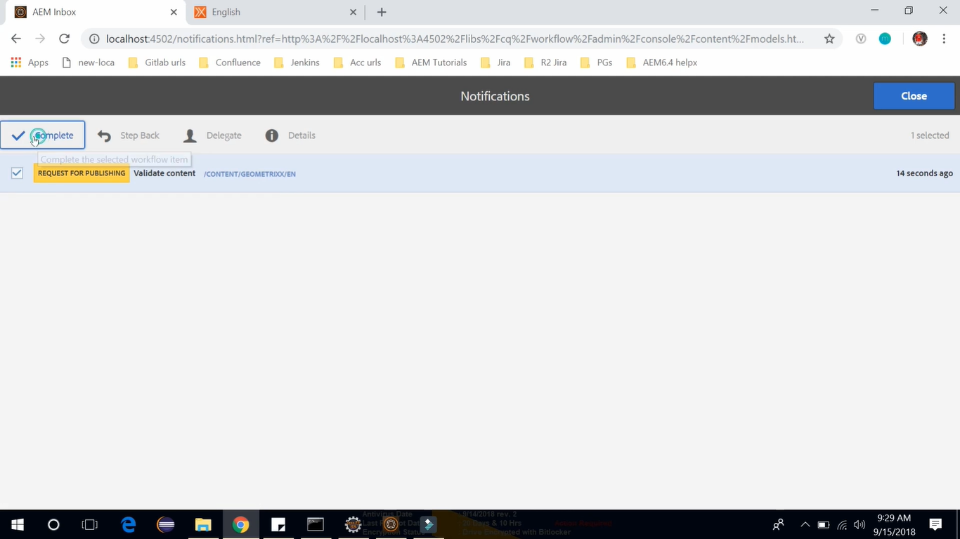

Add the **Comment** shown below --> Click on **Complete** button on Toolbar.

It will complete the workflow.

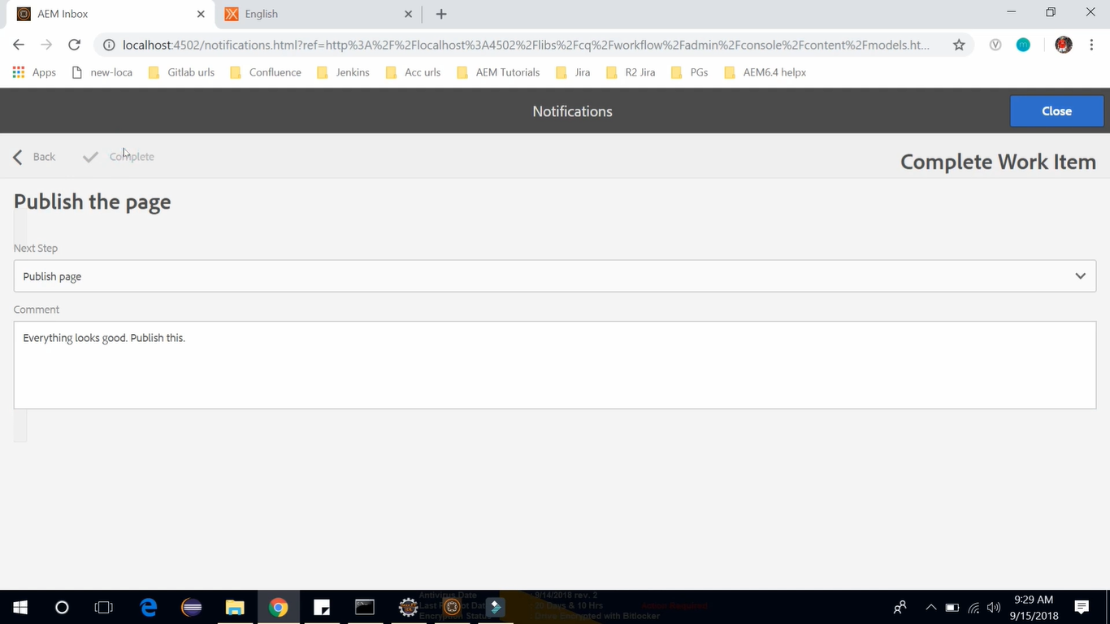

Go to the English page <http://localhost:4502/contetn/geomatrixx/en.html> --> Click **Page Information** icon

This will open **Page Information** panel and we can see a message stating “Modified 4 years ago by Administrator. Page has been published 31 seconds ago by workflow-process-service”.

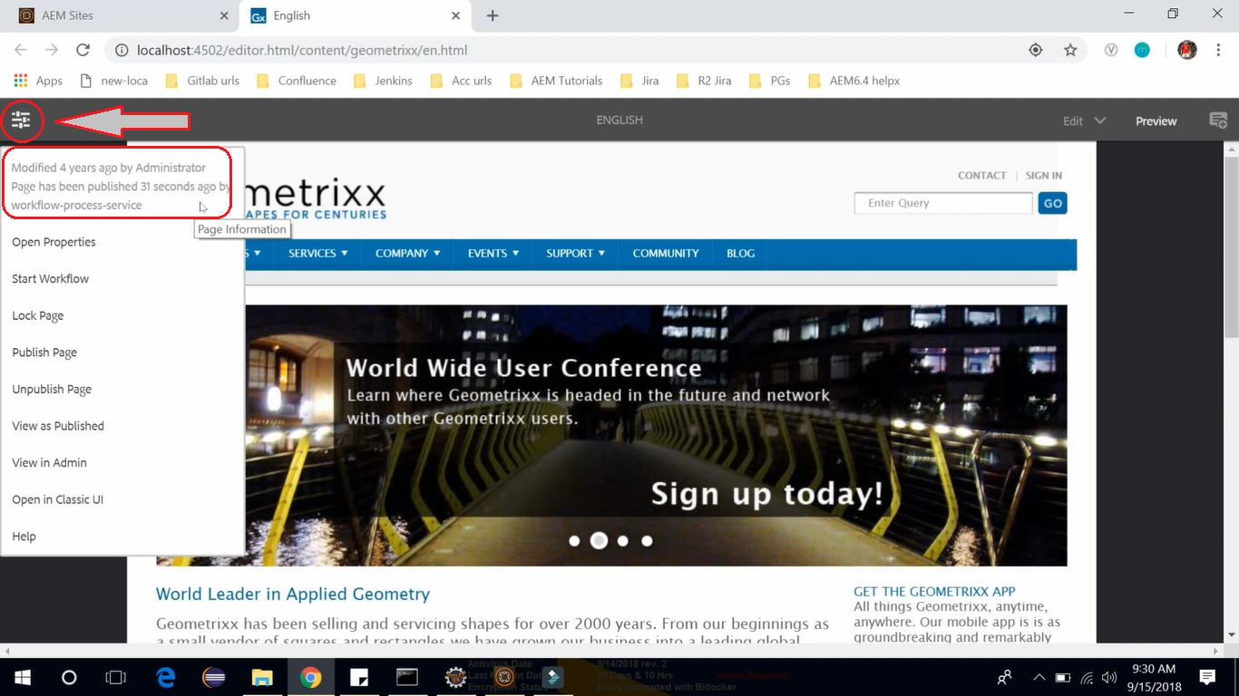

If you publish AEM instance is running you can also go over there and see this page.

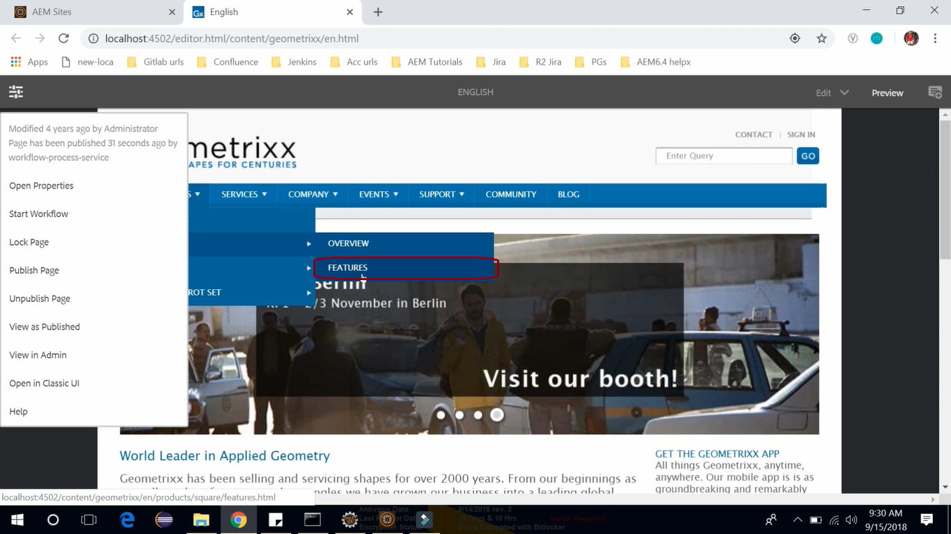

# 85. **DAM Update Asset Workflow**

In this section, we will discuss about out of the box (built-in) **Workflow** i.e. **DAM Update Asset**.

To open it, go to **Product Navigation** (click AEM logo) --> **Tools** --> **Workflow** --> **Models**

Here you can find all the out of the box (built-in) Workflows which AEM provides.

You can find **DAM Update Asset** as the first Workflow in below image.



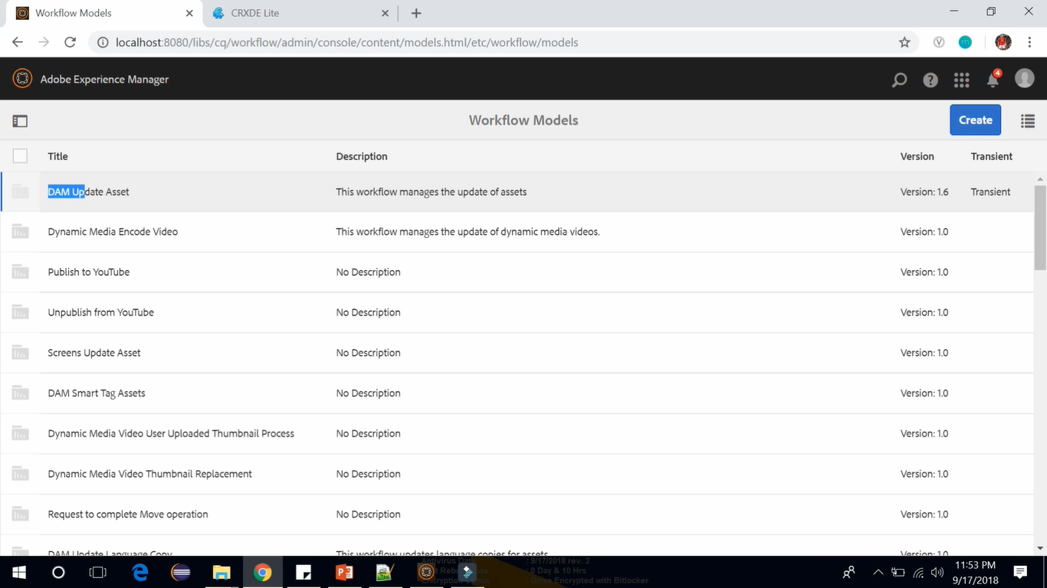

By default, whenever you upload an image to the AEM asset, then, **DAM Update Asset** works behind the scenes. Let’s see how (follow all below images).

Go to **AEM** -> **Assets** Console --> **Files** --> **Demo** Folder --> **Create** button --> **Files** option (to upload image) --> Browse and select and image (e.g. **Pankaj.jpg**) --> You can see image is uploaded --> Double Click to open the image --> Select **Renditions** View --> You can see there are **5 Renditions** available, first one is **Original**, second is **Web** enabled, while remaining are **Thumbnails** of different dimensions.

These renditions of images has been created because of **DAM Update Asset** workflow.

The uploaded image (shown in 5th image --> see page URL) is created within **/content/dam** folder

We had chosen demo folder so this image will be uploaded in CRX/DE **/content/dam/demo** folder.

If you exlpore to open **/content/dam/demo/Pankaj.jpg/jcr:content/renditions** CRX/De node, you will see all the 5 renditions (see image below) which are created due to **DAM Update Asset** workflow.

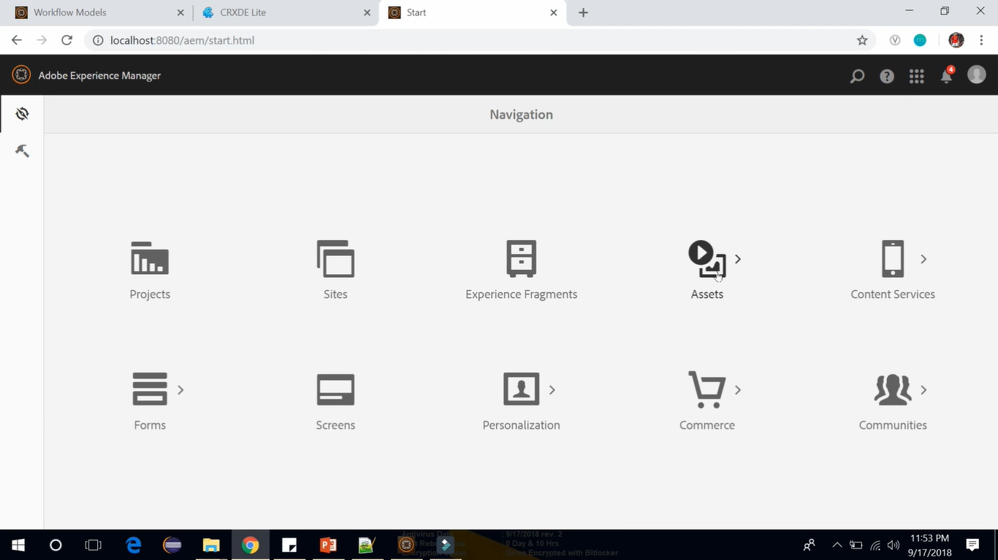

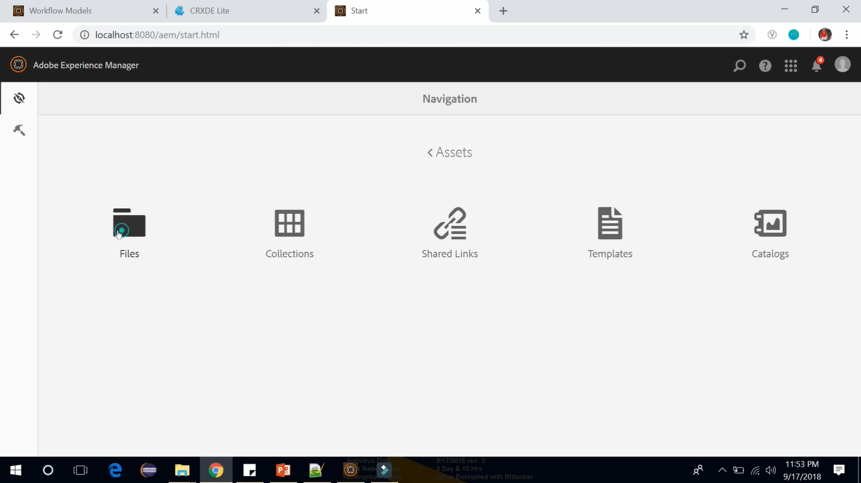

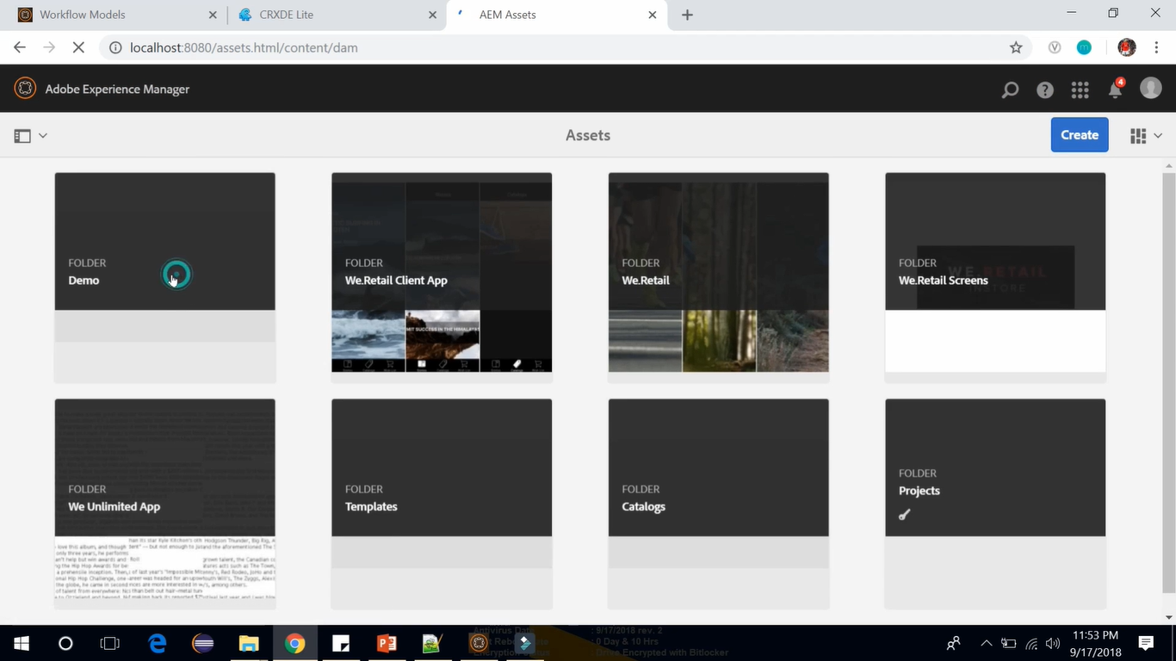

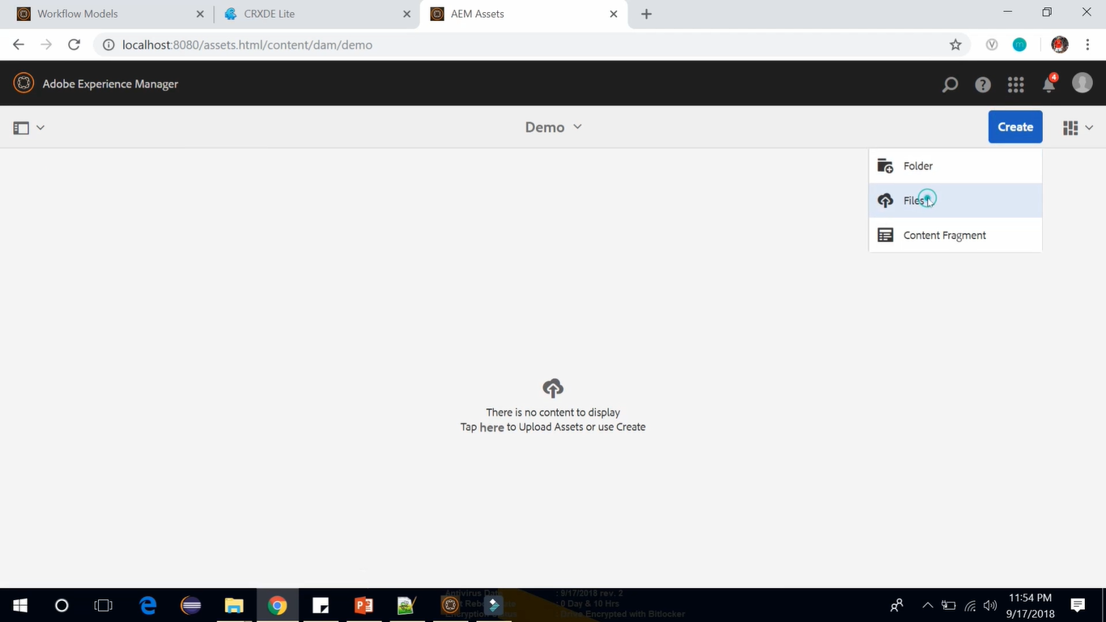

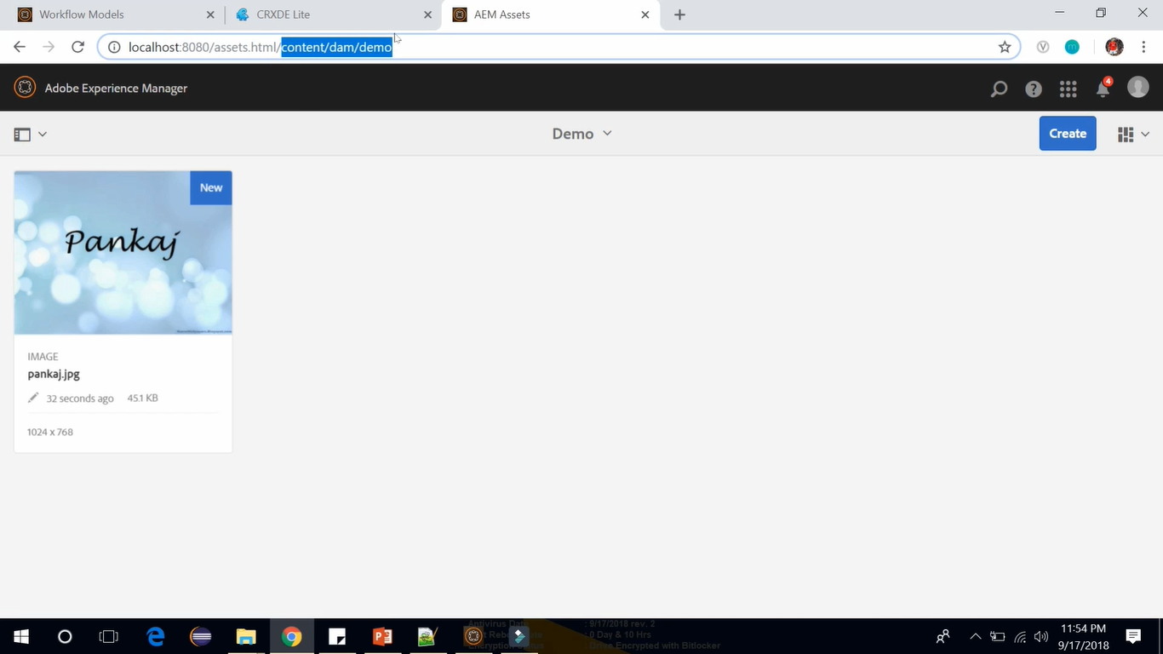

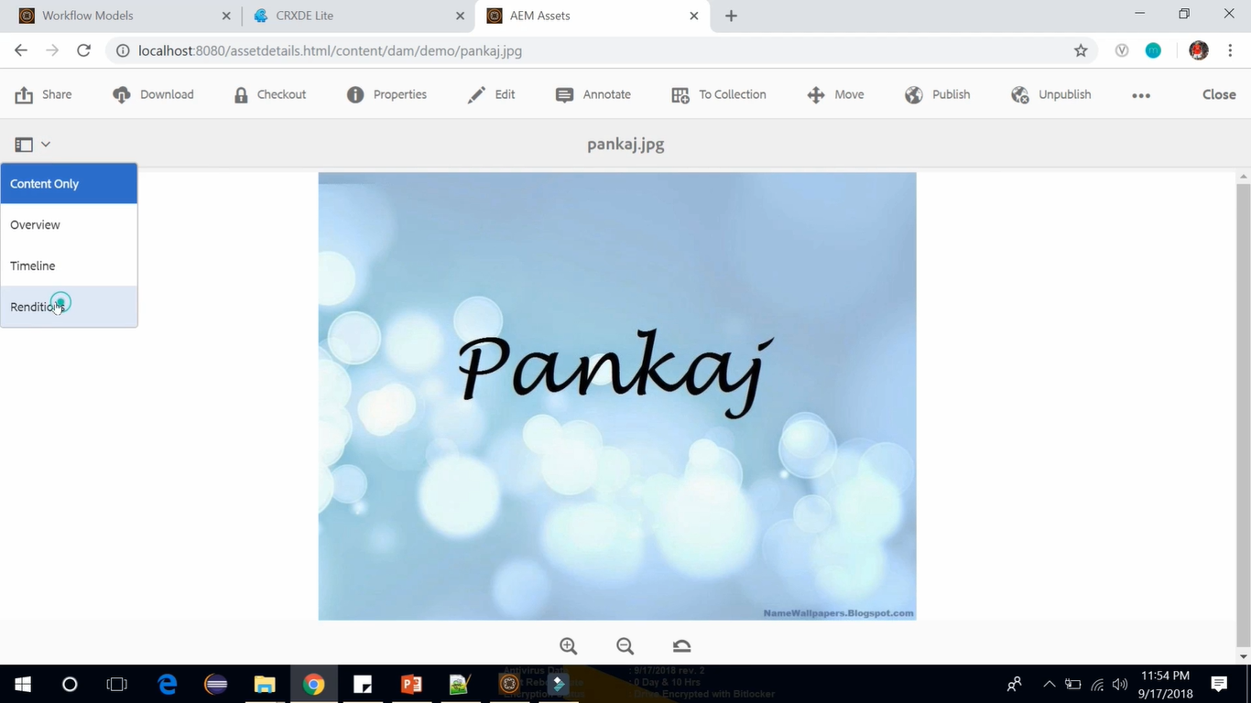

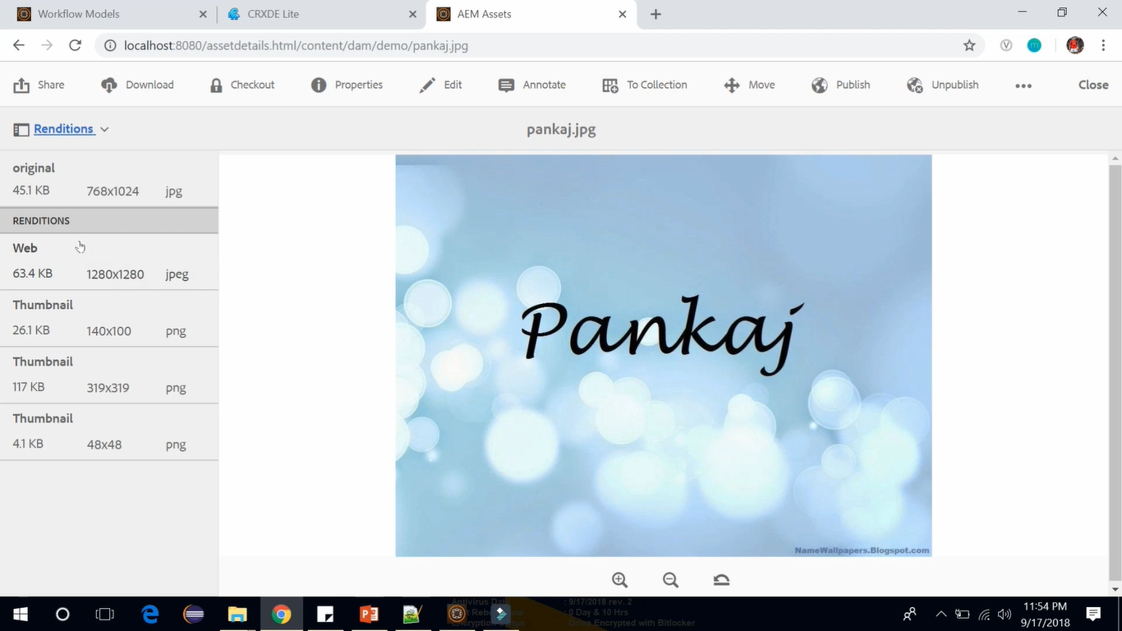

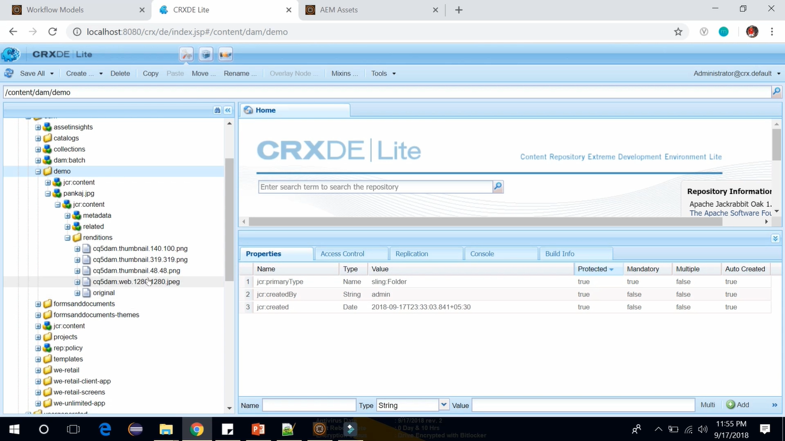

Let’s Edit this **DAM Update Asset** Workflow using below steps

Selecting the **DAM Update Asset** Workflow --> Clicking on **Edit** icon on Toolbar

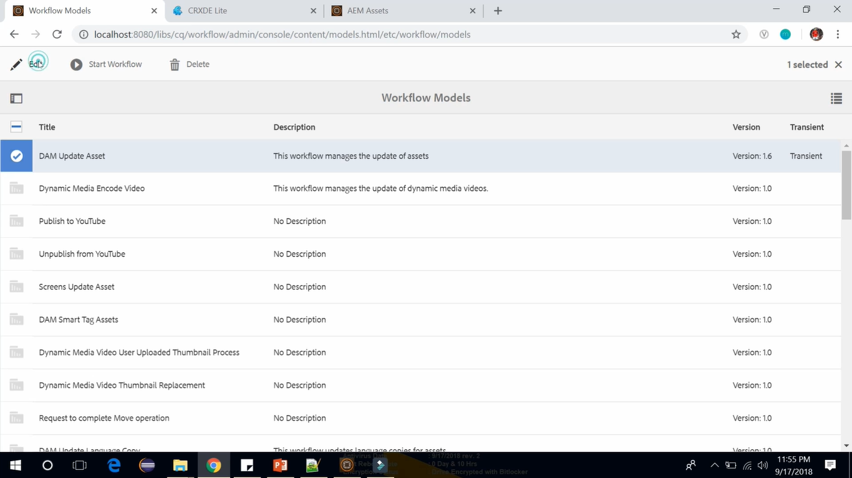

There is a process (image below) in this workflow called **Process Thumbnails**. **Double click** to **Open** it.

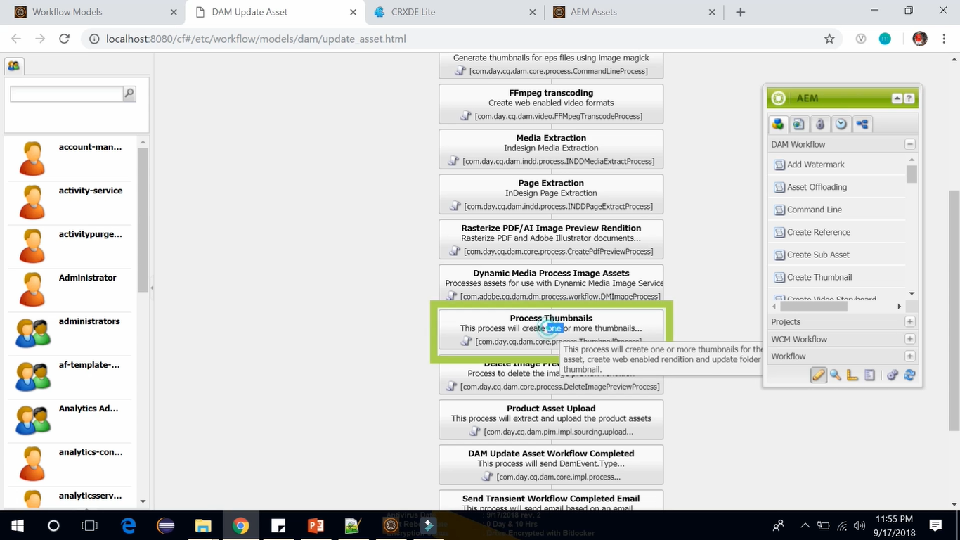

This will open **Thumbnail Process – Step Properties** dialog.

Go to **Thumbnails** tab. You can see 3 dimensions available there.

Go to **Web Enabled Image** tab. You can see 1 dimension with Width 1280 and Height 1280 specified.

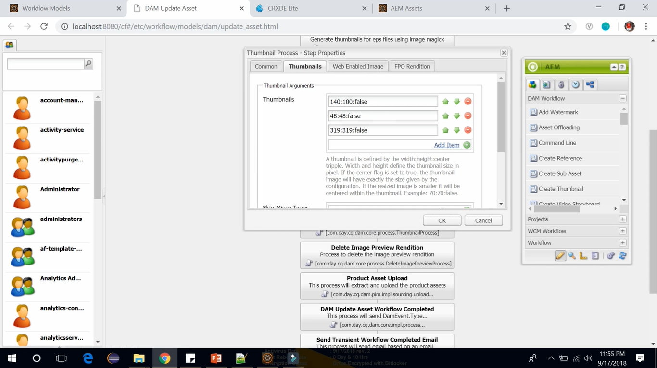 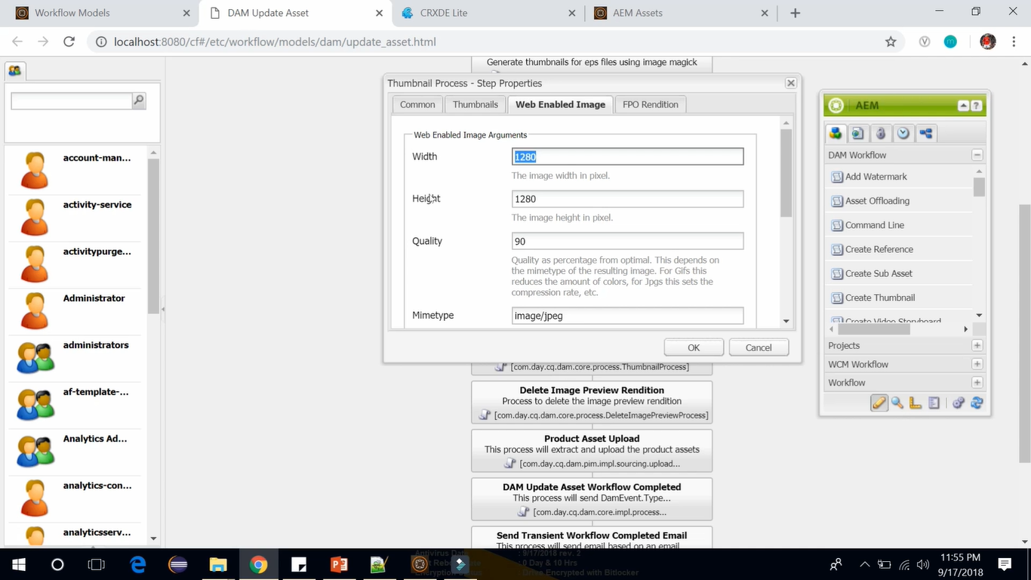

Suppose there’s a requirement to add image of some different dimension then follow steps (below image) **Thumbnails** tab --> Click on **Add Item** link --> **Add dimensions** in newly added Textbox --> Click **OK** --> **Save**

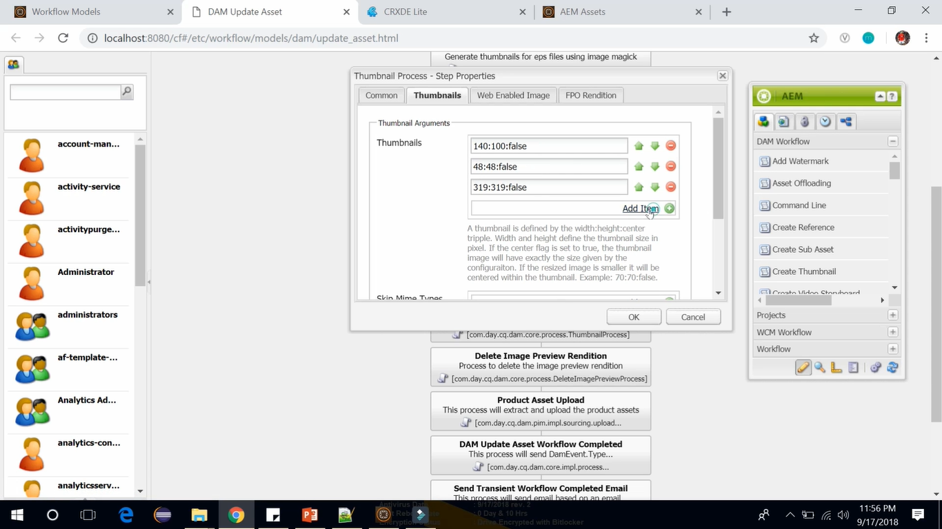 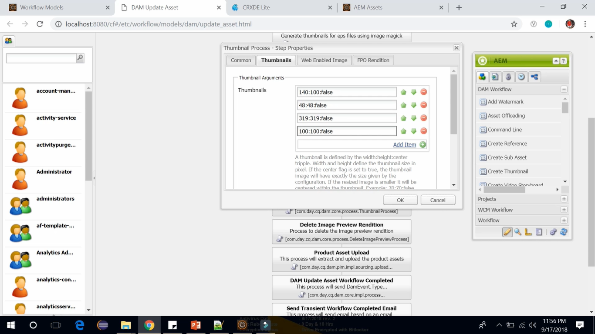

After saving this go back to Asset Console. Upload 1 more image similar way.

Go to CRX/DE --> **/content/dam/demo/622701-early-quotes.jpg/jcr:content/renditions**

You can see there are total 6 renditions now with one newly specified dimension **100 x 100.**

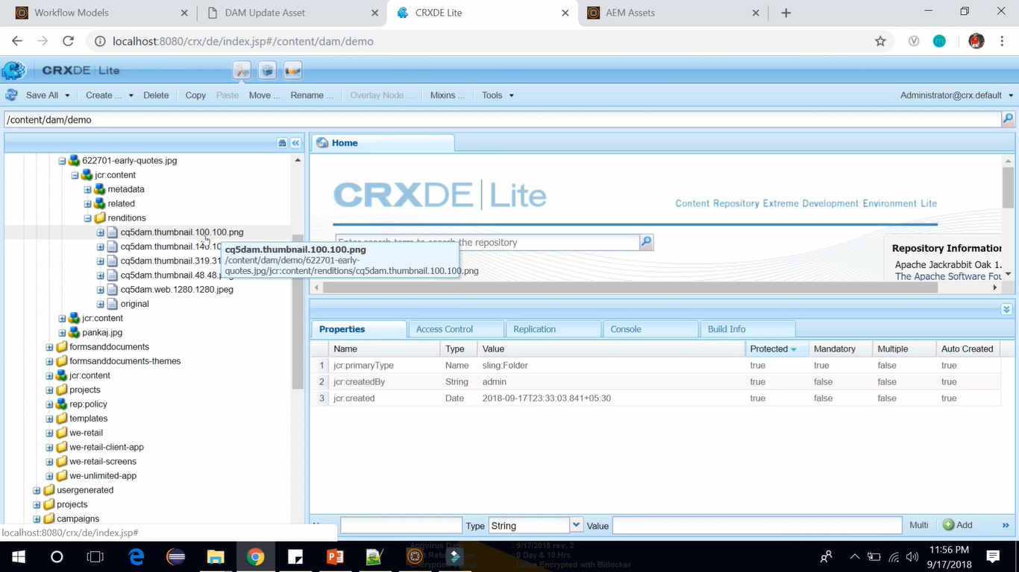

You can also see the image from the Assets. Go to **AEM** -> **Assets** Console --> **Double click** on new image

--> Select **Renditions** View --> You can see **5 Renditions** --> with one newly specified dimension **100 x 100.**

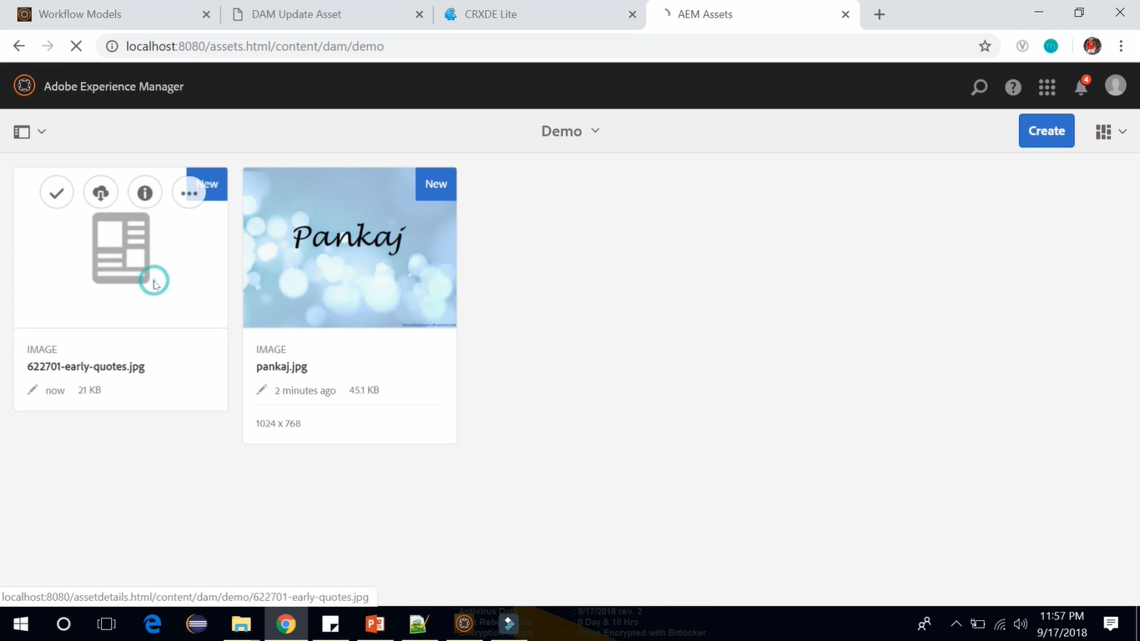

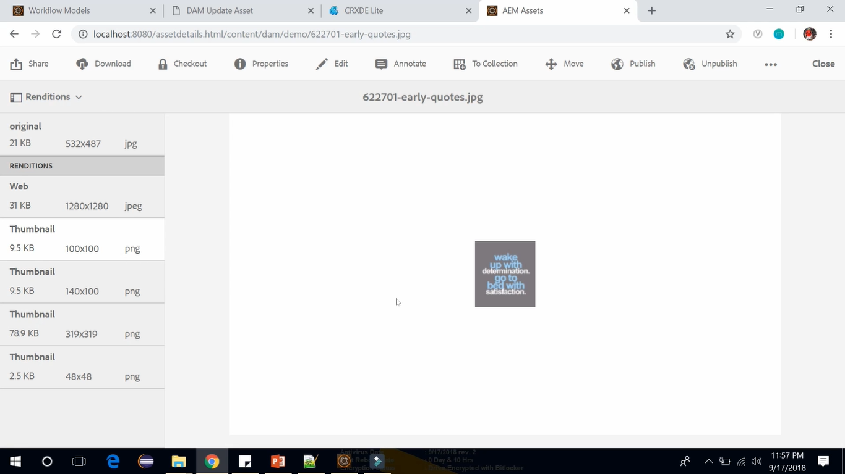

This way you can update existing DAM Update Asset Workflow and create different renditions according to the requirements.

There is one more feature called **Watermarking** which you can add to you images.

It might be helpful in case of branding, promotion, marketing of the company.

Company might want the image with their name or logo as a Watermark over the image.

If you open the **DAM Update Asset** Workflow, in AEM **Component Browser** window, you will see a component called **Add Watermark**.

Drag and drop this component as 3rd step below **Continue Updating** Step.

Double click on **Add Watermark** component to open its Properties (see image below).

Go to **Arguments** tab --> Give **Text** (AEM Tutorial) and **color** (red).

Upload 1 more image and go to page to see the Watermarked image (see image below).

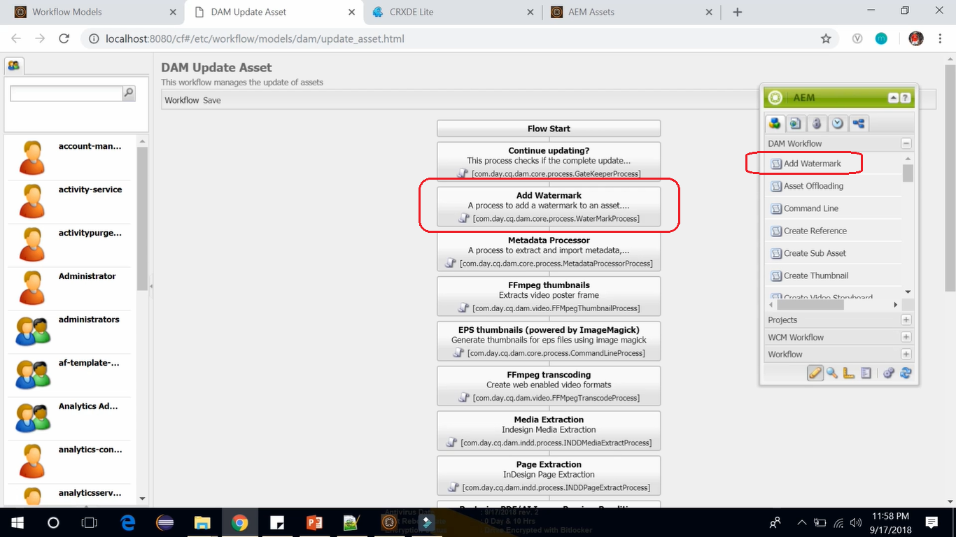

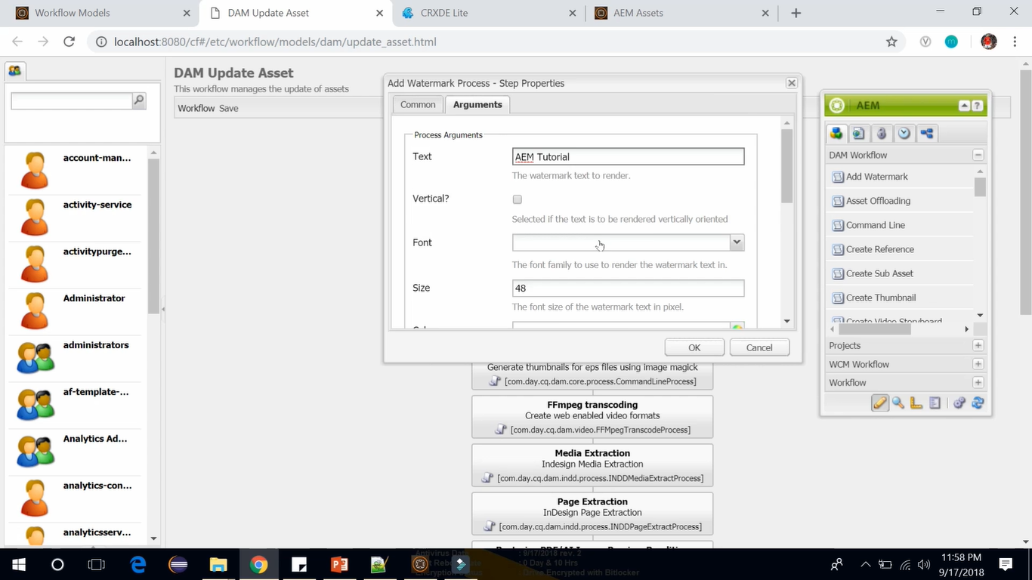 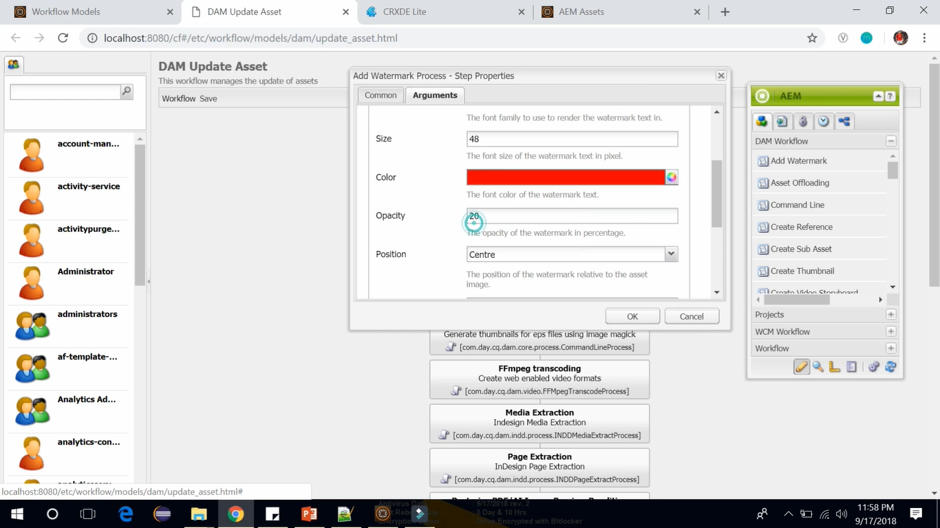

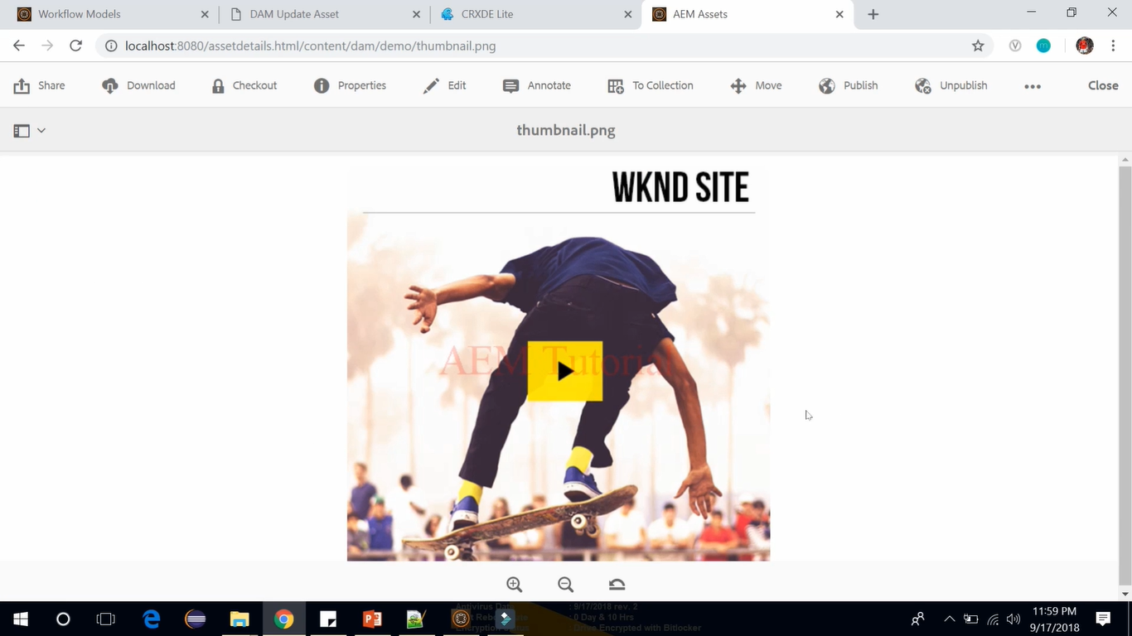

# 86. **Managing Digital Assets**

In this session, we are going to talk about how you can manage and organize digital assets in AEM.

**What is an asset?**

It’s a **binary file** that includes **metadata**, **renditions** and **sub assets**.

An asset is a **digital document** like an **image**, **video** or **audio** file and it can have *multiple* **renditions and sub-assets**. Sub-assets are like slides in power point.

Now, we will look at how we can **add assets** in AEM and how we can **edit** those assets and **set properties**.

**Go to AEM** --> **Assets** --> **Files** --> **Create** folder-->Set Title as **Demo** --> **go into this demo folder**

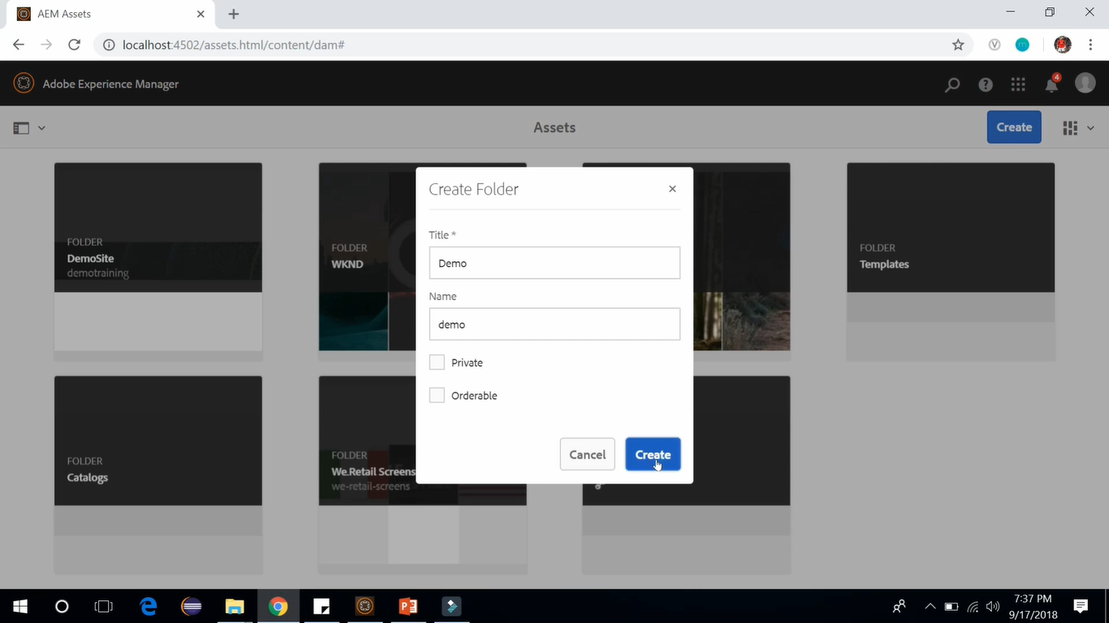

Now, we want to put images within this folder called demo. So, we can upload the images by 2 ways.

**1st** way to upload image: --> **Click** on **Create** --> **Files** --> **browse file** --> **Click on upload**

**2nd** way to upload image: --> **Drag and drop the file**

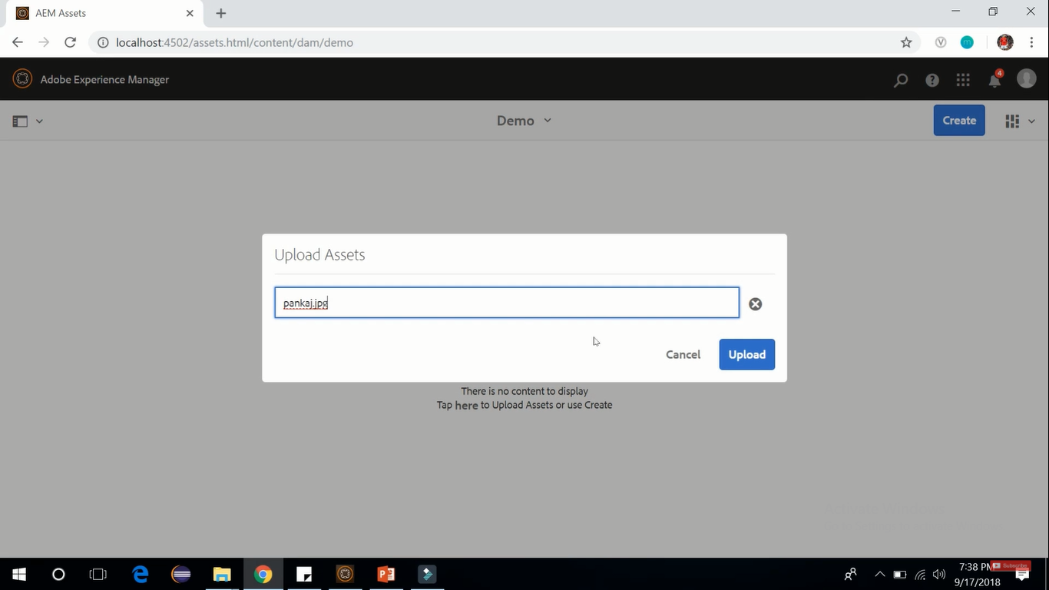

**1st** way to upload image (image above)

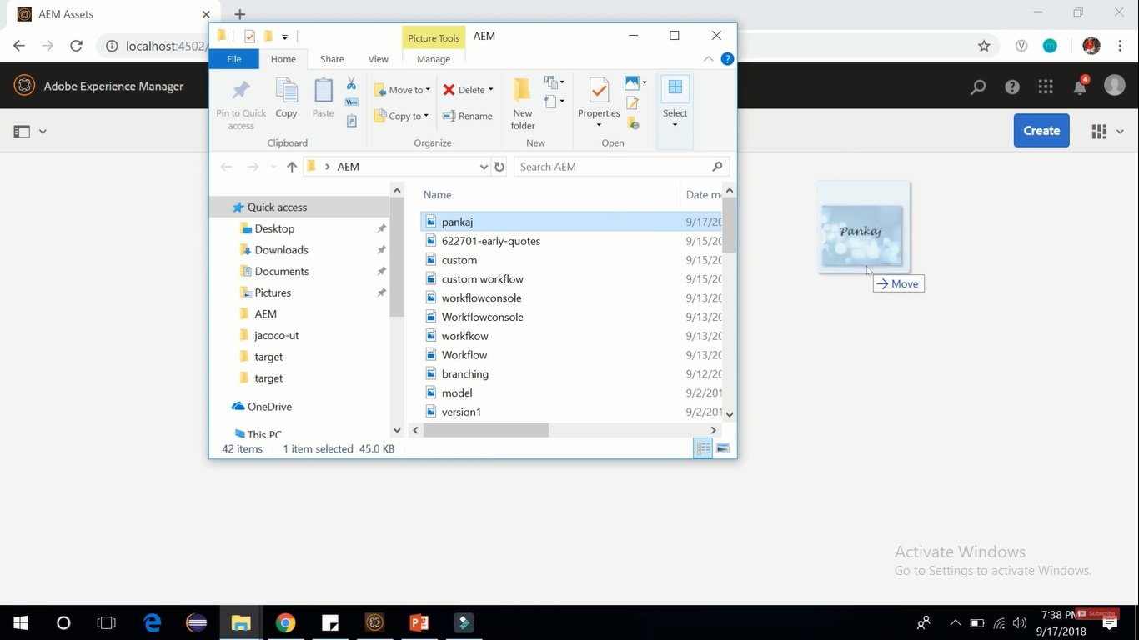

**2nd** way to upload image (image above)

So, on the top you can see AEM is processing an image in its default workflow and that default workflow which is running behind the scene is DAM asset workflow.

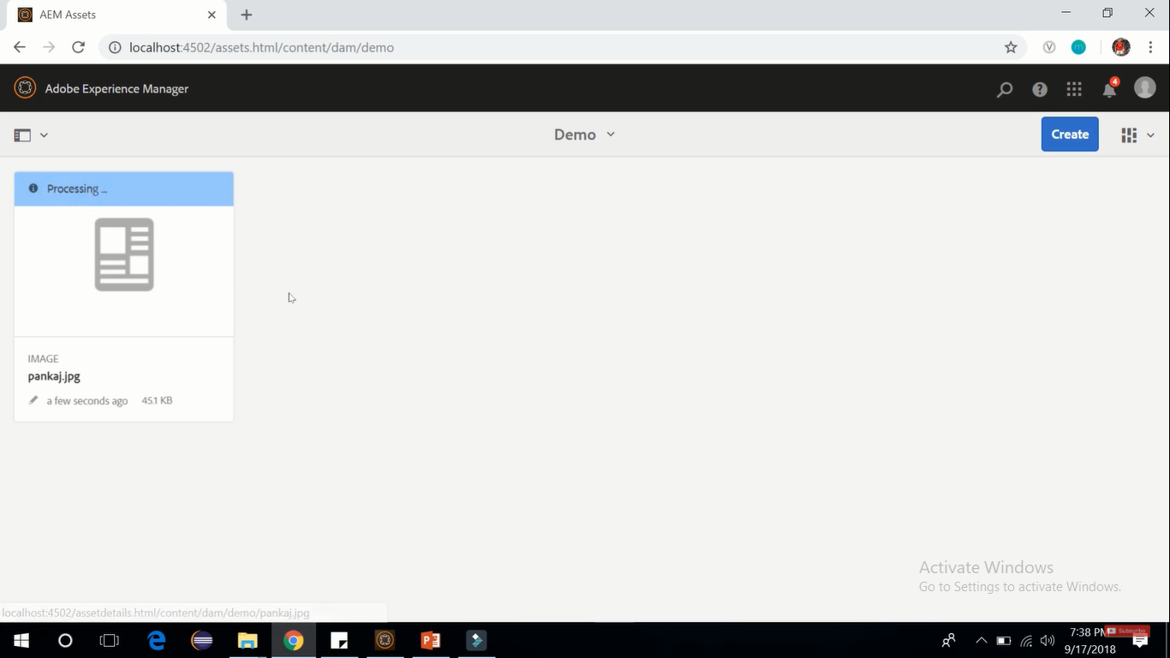

After refreshing you can see image has been **processed** now and it is **showing thumbnail** and the workflow is **DAM asset workflow**. This workflow gets different rendition or sizes of an asset.

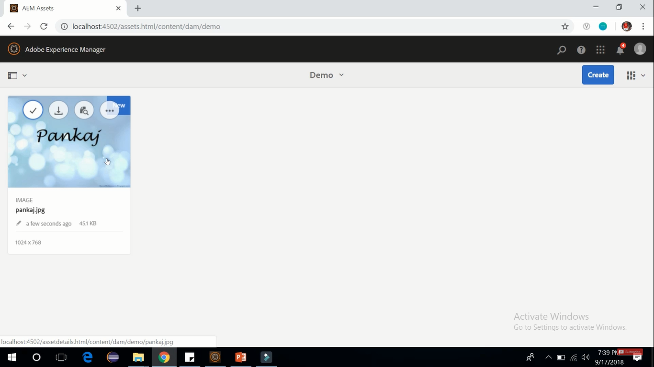

**Click** on this newly added image to open it. Open image in **Renditions mode**.

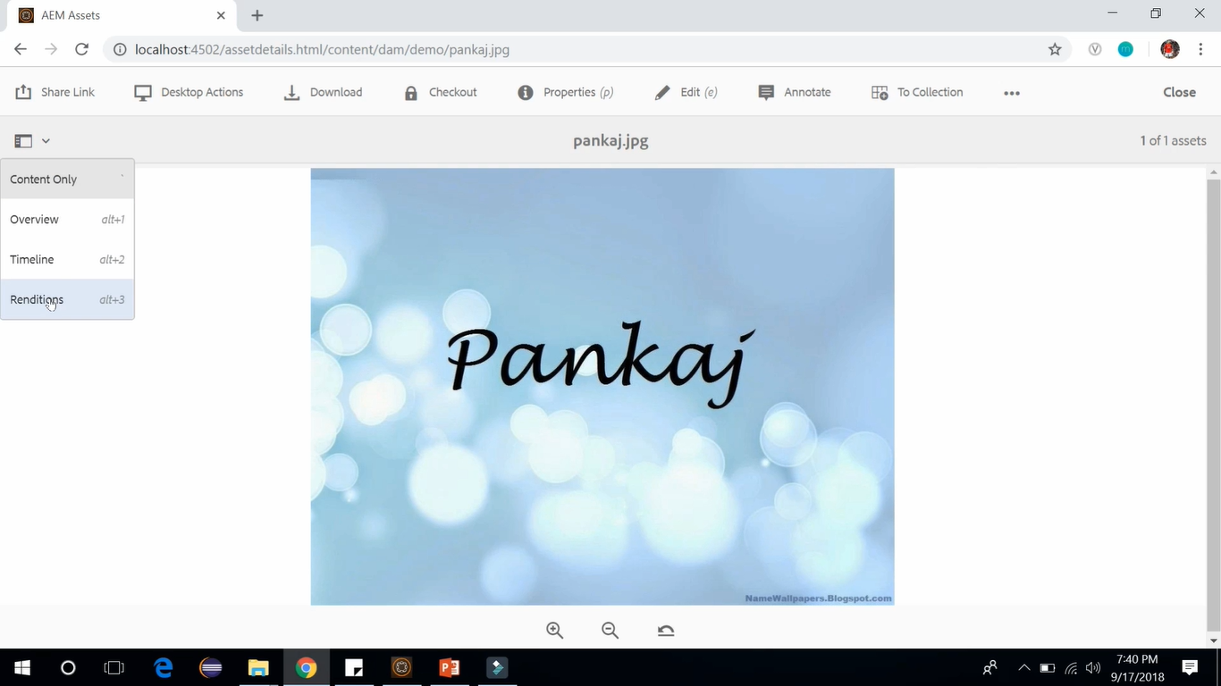

It will show different rendition which are available for this image (See image below).

Renditions available for this image are thumbnail, web and original.

Select original image --> Click **Edit** icon on Toolbar to edit the image like **crop**, **rotate**, **flip**, **border** and **undo** changes. Click on **Save** button after editing the image.

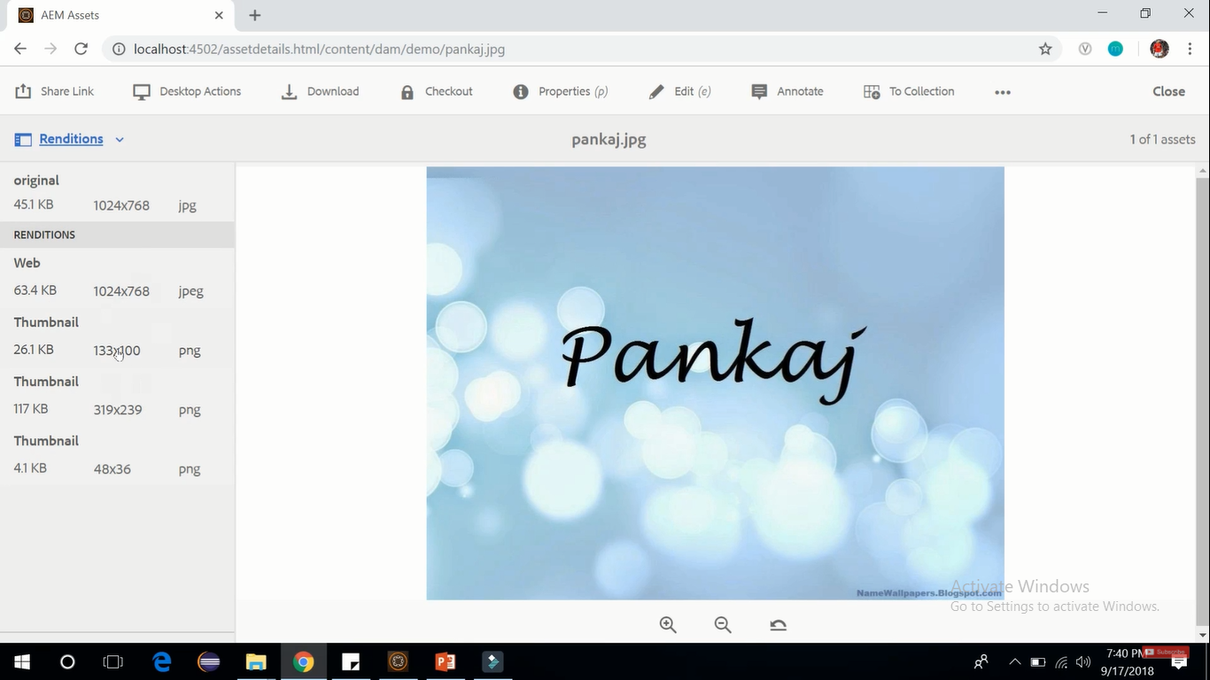

Just like pages, **images** also have series of **properties** that you can **control**.

Click on **Properties** button on Toolbar (see below image) --> It will show **Properties screen** (image below)

There you have different categories of properties available basic, advance, IPTC, IPTC Extension, camera data, Product data, Insights with their individual tabs for each category.

Here, in **Basic** tab we have **metadata** (things like **title** and **description** of Image) and you can also perform **activation** or **deactivation** of the image.

In **Advanced** tab **licensing**, we have **ratings** in the form of stars.

**IPTC** tab (International Privacy Telecommunication counselling) which provides more metadata.

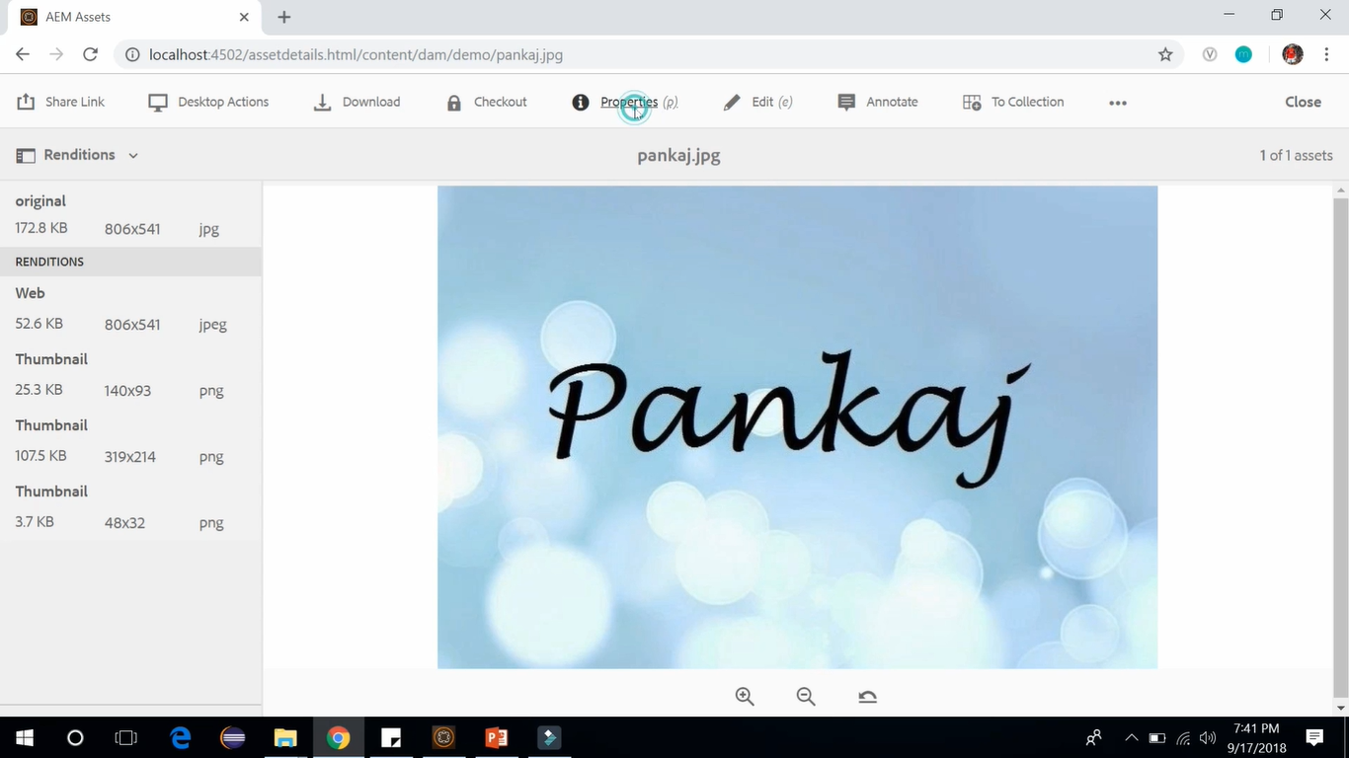

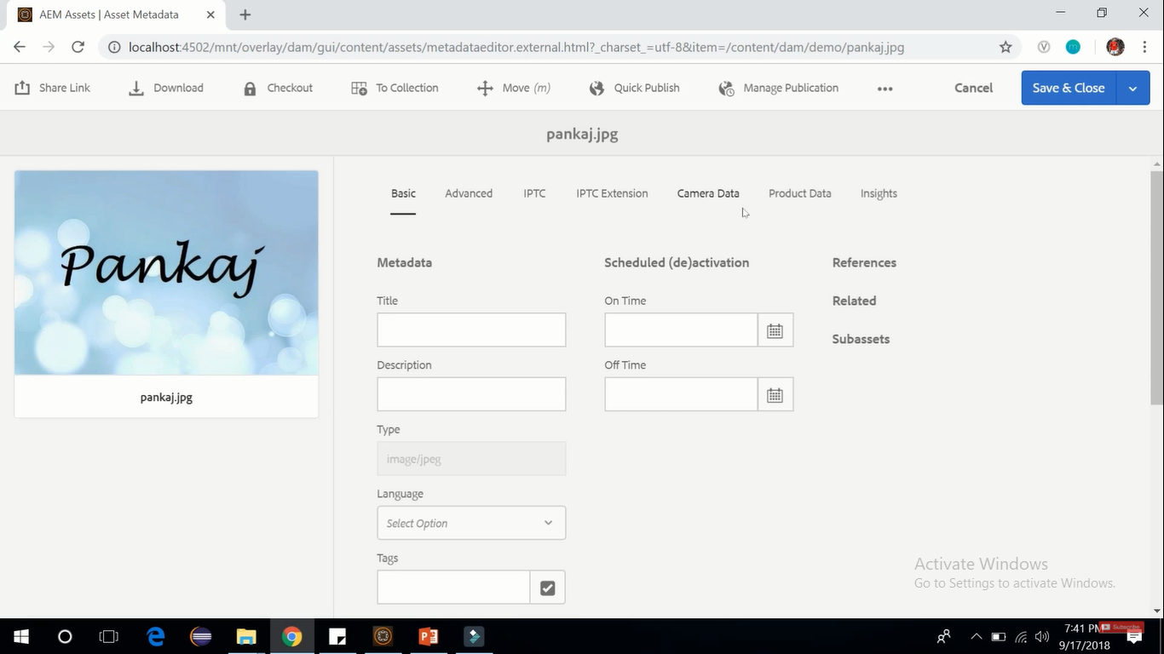

We can **Delete** this image also just click on **3 dots** from right corner and select **Delete** option.

